

**Pearson**

**Higher Nationals in**

**Computing**

PEARSON SET ASSIGNMENT

UNIT 13: Computing Research Project

**Project Final Report**

**Project Final Report**

|  |  |  |  |  |  |  |  |
| --- | --- | --- | --- | --- | --- | --- | --- |
| **Course Title** | **Pearson Higher Nationals in Computing** | | | | | | |
| **Unit** | **Unit 13 - Computing Research Project** | | | | | | |
| **Project Title** | **SMART INTELLIGENCE SUPERMARKET TROLLEY** | | | | | | |
| **Student Name** | **Farha Imthiyaz** | | | | | | |
| **Centre No** | **CSD/17/57/05** | | | **Edexcel No** | | **KJ46494** | |
| **Contact No** | **0765665251** | | | **Email** | | **farhaimthifari123@gmail.com** | |
| **I certify that the given project proposal is appropriate and my own work to the best of my knowledge and I understand that plagiarism** is strictly prohibited and **may lead for penalty.** | | | | | | | |
| **Students Signature** |  | | | **Date** | | | **28/07/2019** |
| **Comments** | | | | | | | |
| **Project Supervisor** | | **Mr.Anis Saboordeen** | | | | | |
| **Date** | | **28/07/2019** | **Signature** | |  | | |
| **Project Coordinator** | | **Mr.Anis Saboordeen** | | | | | |
| **Date** | | **28/07/2019** | **Signature** | |  | | |

**Declaration Sheet**

Presented in partial fulfilment of the assessment requirements for the above award.

I **Farha Imthiyaz** bearing student No **CSD/17/57/05** belonging to batch **CSD-57** of Pearson BTEC Level 5 Higher National Diploma do hereby declare that my final project work entitled **“SMART INTELLIGENCE SUPERMARKET TROLLEY”** Submitted to BCAS is work done by me under the guidance of my Project Supervisor and Coordinator, Department of IT, BCAS School of Engineering & Technology.

This work or any part thereof has not previously been presented in any form to BCAS or to any other institutional body whether for assessment or for other purposes. Save for any express acknowledgements, references and/or bibliographies cited in the work. I confirm that the intellectual contents of the work are the result of my own efforts and of no other person.

And that I shall not submit my project work to any other institute for the award of any academic or professional qualification and/or sell such project work and/or cause any details pertaining to my project work into the possession of any other person or part with such project work in any other manner whatsoever, during or after completion of my studies at BCAS without prior written consent of the Project Coordinator and management.

**Name :** …Farha Imthiyaz………………………

**Signature :** ……………………………………..……

**Date :** ……**28/07/2019**…………………………

**(Must include the unedited statement above. Sign and date)**

# Abstract

Now a days shopping malls are facing lots of problems in many ways. So, for my HND Project I choose to create project based on shopping trolley. Because to reduce waiting queue time and shopping time. I choose smart trolley project because of many reasons. After doing many final projects not use in practically. Because we need to control large area public. That is not practical. But, If we focus small area usable project meant that will be easily use by public and easily control also. Business is day to day developing. Every each organization thinks to overcome from their competitors. If we doing any projects focus on business meant that can be very much success. Business and IT joined projects are valuable. I did smart based and automated shopping trolley (IOT and AI) for my HND project. In supermarket AI will guides customers through the IOT devices.

In trolley, AI will guide customers through the pop up alerts through the display. It will reminds the customers wherever customer need guidance. So, it will reduce shopping time for customers and increase customer satisfaction. AI will analyse the customer data and giving the suggestions and predictions to our customers. When we are shopping time system will analyse last shopping’s and remembering the products which we like to buy. If the products is expiry meant system will inform us. If the customer is male meant if he select any item from female or baby that will inform to customer. Analyse the previous shopping’s budget and remembering the budget if the budget is overrun meant. When customer shopping time system will send the special offer, discounts and points messages. Then, screen will navigate those products places. That system will inform upcoming products which customer like and purchasing most. So, these information will display on display.

In trolley, IOT using ways are; our smart trolley **TFT 5” Display** and **main computer** is connected through Wi-Fi. Then, share the customer and products information. **Shelves sensors** and **TFT 5” Display** is connected with each other through Wi-Fi. When we are crossing the shelves sensor are sending alerts about products discount information. After, finish customer shopping before he or she reaches the counter; counter computer will get products details with prices which customer bought. Then, we can reduce queue waiting time in counter. Every customer looking this facility most. In here **counter computer** and **TFT 5” Display** is connected with each other through Wi-Fi. So, as our main requirement is to reduce customer waiting time in queue and to guiding the customer in the supermarket. So, in our smart trolley we are using IOT in three ways.

From this project we solve many supermarket issues and customer dissatisfaction. From this project, customer of supermarket will increase and wasting time will decrease (Author’s view).

# Contents page

**1. Abstract 4**

**2. Contents page 5**

**3. Statement of Project Details 7**

**3.1 Project Title 7**

**3.2 Academic Question 7**

**3.3 Aims (provide a list) 8**

**3.4 Objectives (provide a list) 8**

**3.5 Proposed Artefact to be developed in brief (if necessary) 8**

**4. Main Section of the Report 9**

**4.1 Introduction 9**

**4.2 Literature Review 10**

**4.2.1 MEPITS 10**

**4.2.2 Critical Evolution (Compare, contrast and evaluate) of MEPITS 11**

**4.2.3 SATHI (PERSONAL ASSISTANT) 12**

**4.2.4 Critical Evolution (Compare, contrast and evaluate) of SATHI 13**

**4.2.5 iCart (The Smart Shopping Cart) 15**

**4.2.6 Critical Evolution (Compare, contrast and evaluate) of iCart smart shopping cart 17**

**4.2.7 AMAZON GO 19**

**4.2.8 Critical Evolution (Compare, contrast and evaluate) of AMAZON GO 20**

**4.2.9 indolytics technology 22**

**4.2.10 Critical Evolution (Compare, contrast and evaluate) of indolytics technology 23**

**4.2.11 Modern-Expo Group (Self-Checkout on the Go (Smart Shopping Cart)) 25**

**4.2.12 Critical Evolution (Compare, contrast and evaluate) of Modern-Expo Group (Self-Checkout on the Go) Smart Shopping Cart 26**

**4.2.13 Flavio Bernardo 27**

**4.2.14 Critical Evolution (Compare, contrast and evaluate) of Flavio Bernado trolley 28**

**4.2.15 Grocer Augmented Shopping (European Project) 29**

**4.2.16 Critical Evolution (Compare, contrast and evaluate) of Grocer Augmented Shopping trolley 32**

**4.3 Research approach and methodologies 34**

**4.3.1 Quantitative research methods 34**

**I. Online surveys 35**

**4.3.2 Qualitative research methods 39**

**4.4 Full details of the Artefact 40**

**4.4.1 IOT using way in our Smart Trolley 40**

**4.4.2 AI using way in our Smart Trolley 40**

**4.4.3 Diagrams for our Smart Trolley 44**

**I. Block Diagram 44**

**II. Flow chart 45**

**III. Schematic Diagram 46**

**4.5 Tools and Techniques: 47**

**4.5.1 Tools 47**

**4.5.2 Techniques 47**

**4.6 Answering the academic question. 48**

**4.7 Plan/Schedule 49**

**4.7.1 Gantt chart 49**

**4.7.2 Work break structure 49**

**4.7.3 Active network diagram 51**

**4.7.4 Time plan with Resources 51**

**4.8 Cost Analysis 52**

**4.9 Conclusions 52**

**4.10 Critical evaluation of the product 53**

**4.11 References and Bibliography 55**

# Statement of Project Details

## 3.1 Project Title

*SMART INTELLIGENCE SUPERMARKET TROLLEY*

## 3.2 Academic Question

|  |  |
| --- | --- |
| What is this Project about? | This is a project of implementing a smart trolley using with IOT (Internet Of Things) and AI (Artificial Intelligent). |
| Why is this project for? | * This project was we implemented as a final project in HND. * I choose this smart trolley because after doing many final projects not use in practically. Because we need to control large area public. That is not practical. But, If we focus small area usable project meant that will be easily use by public and easily control also. * Business is day to day developing. If we doing any projects focus on business meant that can be very much success. Business and IT joined projects are valuable. * This Smart trolley with IOT and AI is increase customer satisfaction and reduce waste time. * In supermarket AI will guides customers through the IOT devices. |
| When will do this project? | This project period is about six months. Eleventh of January 2019 is the date which started for planning. Three weeks for project Proposal. After that researched about project and implemented the project. Finally, On 29th of July, We have to submit this Project. |
| Who will do this project and who are involving to this project? | This project did by with the guidance of Research Project Lecturer Mr. Anis Saboordeen and myself. This project is mainly focus for clients. They are Supermarket owners, staffs, and customers of supermarket. |
| How you did this project? | * First step I researched about project in clear and planned the project. * Then, I did project proposal. * Then, I collected our hardware and software requirements. * We research continuously because to update new features to our project. * Then, I studied about programming for IOT devices and AI coding. * Then, we implemented Artifact first. * Then, we implemented the AI. * We created an Artifact. * After that we tested the project. * Finally, we will submit this project. |

## 3.3 Aims (provide a list)

* To create best AI and IOT base Artifact for Supermarket trolleys.
* To get high customer satisfaction from these Supermarket trolleys.
* To reduce the queue waiting time and wasting time in supermarket.
* To reduce labor cost.

## 3.4 Objectives (provide a list)

* Learn about IOT
* Learn Arduino and its coding
* Learn AI platforms and Python coding
* Buy hardware IOT devices.
* Customers can add products to trolley that will automatically add cost and details of the products in the system.
* Customers can search items through the smart trolley will guide them where the products is placed in the store.
* Customer has limited access to these smart trolleys.
* When we are using smart trolley shopping will be easy, comfortable and speed of services.
* The company can manage the products in a convenient manner.
* Automated self-billing by customer.
* Hassle free shopping.
* Maintaining individual Customer Purchase data.

## 3.5 Proposed Artefact to be developed in brief (if necessary)

* We collected the RFID tags, RFID readers, TFT 5” Display and sensors for shelves.
* First, we connected to the power.
* After that, we connected the RFID readers, TFT 5” Display and sensors for shelves in the Microcontroller.
* After that, we programmed in Micro controller software platform.
* After that, RFID tags with products scanned by RFID Readers.
* Then, we programmed for AI.

# Main Section of the Report

## 4.1 Introduction

IOT (Internet Of Things) meant devices connected with each other and share (communicate) the information through the network. AI (Artificial Intelligent) meant as the name suggests is the tech behind artificially recreating human intelligence, by making a software that understands repetitive human habits. AI involves machines that can perform tasks that are characteristic of human intelligence. So, in our smart trolley project we included IOT with AI.

I choose smart trolley project because after doing many final projects not use in practically. Because we need to control large area public. That is not practical. But, If we focus small area usable project meant that will be easily use by public and easily control also. Business is day to day developing. Every each organization thinks to overcome from their competitors. If we doing any projects focus on business meant that can be very much success. Business and IT joined projects are valuable. This Smart trolley with IOT and AI is increase customer satisfaction and reduce waste time and reduce waste cost. In supermarket AI will guides customers through the IOT devices. We developed this project step by step. First step is planning. After that main part is implementing and completing with testing the project (Author’s view).

## Literature Review

### MEPITS

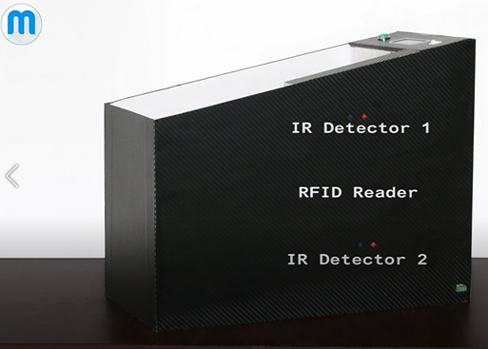Mepits Company has innovate Smart trolley with IOT. Which is used two IR detectors, RFID Reader, Micro controller, Bluetooth module, Bill Button, LCD Display, Power Switch, RFID tags and 12V Battery. This will process like this. When Product adding IR detectors will conform the products added or removed. There are unique RFID tags. Then, RFID readers detect the RFID tag products and then send Product name and price to LCD Display. In this system same product can add multiple times and can remove any products. After, shopping completed then press the Bill button then, Bill which meant total price with product details send to mobile application by Bluetooth. There is a power supply by 12V battery.

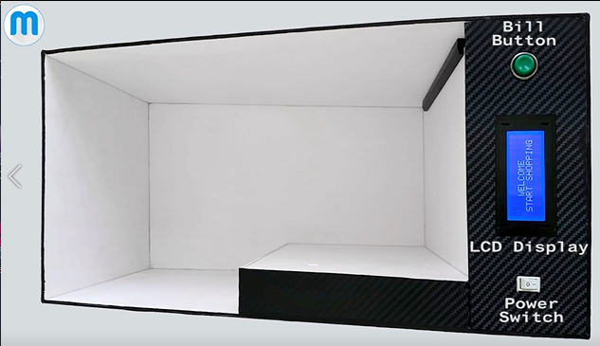**IOT-** When Bill button press its sends the whole total price with product details send to mobile application via Bluetooth. So, this trolley and mobile Application is connected with each other by Bluetooth network.

**(Figure 1- This is a Figure of RFID Reader and IR Detectors)**

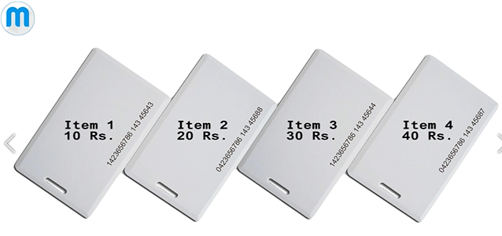

**(Figure 2- This is a Figure of RFID tags)**

**(Figure 3- This is a Figure of Bill Button, LCD Display and Power Switch)**

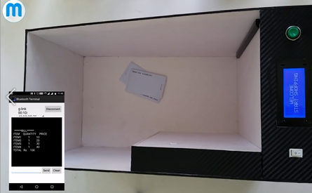

**(Figure 4- This is a Figure of Mobile application output when we press the bill button)**

(www.youtube.com/watch?v=EgUB0mW6zRc&t=2s, n.d.)

### Critical Evolution (Compare, contrast and evaluate) of MEPITS

We got ideas from this Mepits Company Smart trolley to our smart intelligence supermarket trolley. In Mepits trolley they used two IR detectors, RFID Reader, Micro controller, Bluetooth module, Bill Button, LCD Display, Power Switch, RFID tags and 12V Battery. From that we also used some of those devices.

We used two Tag Venders instead of IR detectors. Because, When Product adding Tag Venders will conform the products added or removed. We used TFT 5” Display instead of LCD Display. Because our theme is this smart trolley have to connect with Artificial Intelligence. When we connected with it that it gives most of information about products and guides the customer. So, we used TFT 5” Display to show all these information to customer. So, LCD display can’t do many actions at the same time. According to my project TFT 5” Display is the best to do multiple tasks at the same time. We also used Microcontroller to program to our project.

We also used RFID readers detect the RFID tag products and then send Product name and price to TFT 5” Display. We also used unique RFID tags to products to scan the product by RFID Reader. Because it will attach with product. Each product has unique tag. By that tags product details will scan by RFID Reader.

We didn’t use Bluetooth module and Bill Button. We didn’t develop any mobile application for our smart trolley. According to their smart trolley, the product has unique RFID tags and RFID reader will read the RFID tag in the products. That products details will go to LCD display. If customer press Bill button the whole total price with product details send to mobile application via Bluetooth. So, this trolley and mobile Application is connected with each other by Bluetooth network. So, they used Bluetooth module.

In our smart trolley, we have authentication screen in TFT 5” Display. Then, those customer can login or sign up by TFT 5” Display. SD Card C10 will store the customer data in our smart trolley project and send those data to main computer through the Wi-Fi. Products purchase details of each customer that meant whole total price with product details are store in SD Card C10 and send to main computer through the Wi-Fi. In this Mepits; they used 12V battery for power supply. But we used Power Adapter. Because instead of battery power adapter is very much sure in power supply. Battery can sometimes fail.

If Mepits Company Smart trolley use AI for their trolley meant that can be more success. Because, this AI involves trolley that can perform tasks that are characteristic of human intelligence. From that, they can increase understanding of the customer / target customer, Segmentation, learning from user behaviour and on-site data, Predicting customer preferences which meant seek to show relevant products at the right time and using previous data algorithms can predict customer preferences. So, from these data AI will assist customer in the whole shopping process. Through that customer satisfaction will increase. So, we can cover our main aim in here.

Finally, for our smart trolley we got lots of idea from this Mepits project. In our project, some of the ideas we took and rest of ideas we omit according to our project requirements.

(Author’s view)

### SATHI (PERSONAL ASSISTANT)

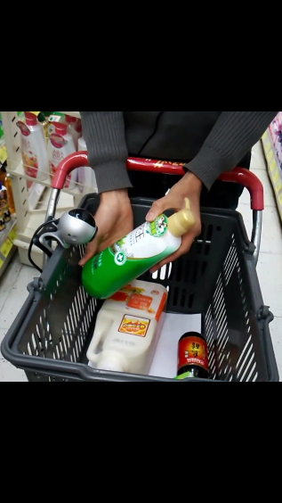This is a personal assistance that will guide to buy things in supermarket. It guide us in voice cut. There is a scanner and hand phone in supermarket trolley. So, if we choose any item in supermarket then we must scan that item from scanner. Then that SATHI will provides all the necessary information about that product though its voice system in our own language. Such as price, expiry date, country of manufacture, how to use it and valid offer and many more. Every customer has unique account in the supermarket. SATHI personal assistance in server computer.

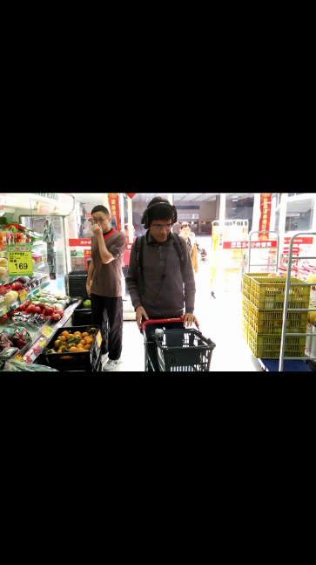**When customer enter the supermarket sensors in supermarket identify them and according to their account they will guide by personal assistance.**

**(Figure 5- This is a Figure of scanner scanning a Product)**

**IOT-** scanner and personal assistance is connected with internet and share the information. Input from scanning output from voice. After bought items that personal assistant is connected with bank. All the Payment done in credit card.

**(Figure 6- This is a Figure of Trolley with Scanner and headphone)**

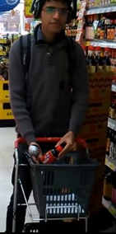**AI**- analysing last shopping’s and remembering the products. If the item expiry date meant it will inform. From the **unique identification** that AI know that customer’s gender. If the customer choose any product not related (if customer is male, if he selected the products female or baby products meant) it will inform. Analyse last shopping’s budgets and it will automatically inform about current budget status (if budget is overrun than last shopping’s that will inform). Finally after whole analysing that will inform special offers, discounts and upcoming customer interested products.

**(Figure 7- This is a Figure of Personal Assistance inform about details of scanning product through the headphone)**

(www.youtube.com/watch?v=jfzmetXKJs4&t=49s, n.d.)

### Critical Evolution (Compare, contrast and evaluate) of SATHI

SATHI is a personal assistance which is customize for business organization. This business organization mainly store every data in main computer. Through that data; SATHI will guide to buy things in supermarket. It guide customers in voice cut. In our Smart trolley we also used like this same technology. We used main computer to store every data of customers, products which customer purchased and products details. SATHI is an Artificial Intelligence (AI) which is analysing the data and guide customer in the supermarket. Same way we are also using AI to analysing the data and guide the customers.

SATHI guides customers through the voice. So, they use head phone. But, we are not using voice cut because, that will be most difficult to wear that headphone and do the shopping for customers. That is not that much of practical and not in new trend. We are using this smart trolley to increase business by new trend. But, if we use like headphones in supermarkets meant it will reduce the demand of organization. So, we omit that. Instead of headphone if we use small speaker meant, it will again raise another problems in supermarket. Shopping malls meant there are lots of customers are shopping. If we use small speakers meant sound issue will increase in the supermarkets. So, customer satisfaction will reduce. Also, not all the customers has concentrate in two ways. That meant if customer have to focus on screen and listening by sound in headphone or speaker. So, in our smart trolley our AI is in main Computer. It will guides the customer through the messages in display. So, all the products details, login and guiding messages everything show in TFT 5” Display. So, customers need to focus only in TFT 5” Display.

They are using scanner. Because, if customers choose any item in supermarket then they must scan that item from scanner. Then that SATHI will provides all the necessary information about that product though its voice system in their own language. Such as price, expiry date, country of manufacture, how to use it and valid offer and many more. In our smart trolley we used RFID reader for instead of scanner. Because barcode scanner is popular use in shopping malls. But, RFID readers and RFID tags are using in latest trend. SATHI is guiding information about that product though its voice system in their own language. But, in our smart trolley we used only English language in display. So, in this era almost everyone knows business English words. So, that is very easy to understand than their own language. Every customer has unique account in the supermarket. That SATHI personal assistance in server computer. In our smart trolley also every customer have unique account. Then, only according to them AI can guide them.

In SATHI IOT using way is **Scanner** and **server computer** is connected with internet and share the information. Instead of that, our smart trolley **Display** and **main computer** is connected through Wi-Fi. Then, share the customer and products information. **Shelves sensors** and **TFT 5” Display** is connected with each other through Wi-Fi. When we are crossing the shelves sensor are sending alerts about products discount information. After, finish customer shopping before he or she reaches the counter; counter computer will get products details with prices which customer bought. Then, we can reduce queue waiting time in counter. Every customer looking this facility most. In here **counter computer** and **TFT 5” Display** is connected with each other through Wi-Fi. So, as our main requirement is to reduce customer waiting time in queue and to guiding the customer in the supermarket. So, in our smart trolley we are using IOT in three ways.

In SATHI that Input from scanning output from voice. Instead of that in our smart trolley we are also scanning by RFID readers and output from messages in display. In SATHI, after bought items that server computer is connected with bank. All the Payment done in credit card. Instead of that in our smart trolley; our main computer also is connected with bank. But, we can do direct card transaction or manual. Because, every customers don’t have those card facility. If they have that facility meant also some of them don’t pay from card. Because some of security reasons.

In SATHI AI is using ways are analysing last shopping’s and remembering the products which they have to buy. If the item expiry date meant it will inform. From the **unique identification** that AI know that customer’s gender. If the customer choose any product not related (if customer is male, if he selected the products female or baby products meant) it will inform. Analyse last shopping’s budgets and it will automatically inform about current budget status (if budget is overrun than last shopping’s that will inform). Finally after whole analysing that will inform special offers, discounts and upcoming customer interested products.

In our smart trolley we also using AI for those purposes. Because our smart trolley project main aim is to increase customer satisfaction by using AI. So, we also including these features for our trolley. But, we are omit that according to customer’s gender products suggestions. Because, if the customer can be any gender. But customer need to buy products for family meant he/she need to select the products unrelated to their gender. So, that is not in practical. Also, if the customer send another friend or family member to supermarket instead of him/her. In that case instead person can be opposite gender. So, their selection also unrelated to their gander.

Finally, for our smart trolley we got lots of idea from SATHI. Because, this SATHI is best AI based trolley. So, that will guides customers as assistance. So, in our project, some of the ideas we took and rest of ideas we omit according to our project requirements.

(Author’s view)

### iCart (The Smart Shopping Cart)

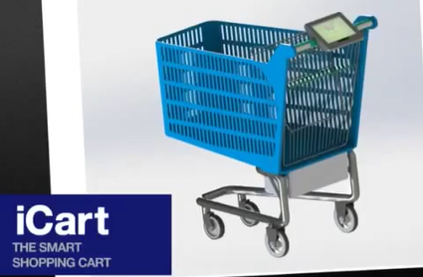iCart smart shopping cart is a company which introduces to market smart trolley. This smart trolley is an electric, comfortable, user friendly and can fast shopping. This smart trolley shopping speed is 252km/h, Autonomy is 8 hours and weight is 72kg. This base is made of Steel AISI 304 and basket is made of Polypropylene 30% Glass fibber. Powered by Electric motor, Wheel hub motor and FG-R-88. Power is 200W, Torque is 5,3Nm and 24-36 VDC/ 8” – 6”. There is a Drive and Control system. That will guide customer to turn right, turn left and go straight. This trollies use Battery system; they are Lead acid batteries and vision battery. This Autonomy is 8 hours, Voltage 24V/ Capacity 24 Ah and 576Wh. There is a charging system and after shopping there is a pay money method call Pay Pass.

**(Figure 8- This is a Figure of iCart shopping smart Cart)**

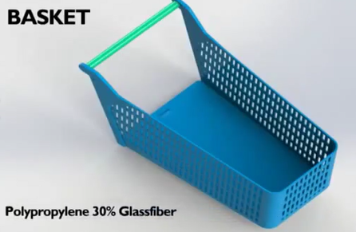This trolley screen there is we have to type our username and password. Then, we will login to our account from screen. There is a server computer. This store every customer accounts and details. After that server computer will analyse our previous shopping and guide us what we have to buy through the screen. After shopping we can pay money from Pay Pass. There are two RFID readers in two sides. Then, trolley is middle. That trolley products will scan by RFID readers and that every information will send to that machine. From the card payment we can pay our amount.

**(Figure 9- This is a Figure of iCart’s Basket)**

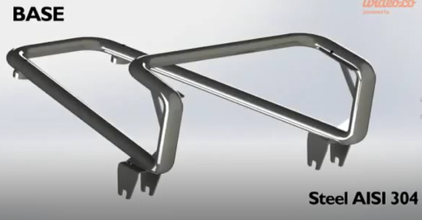**IOT-** iCart screen and server computer is connected via network. When every shopping complete that trolley is scan by both side RFID readers. From that every products details in trolley and total amount is send to that machine. Machine is connected to bank. We must pay our payment throught the card.

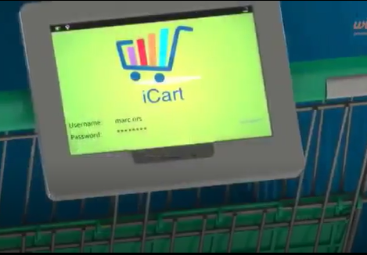**AI-** Server computer has AI and that will analyse our previous shopping and guide us what we have to buy through the screen.

**(Figure 10- This is a Figure of iCart’s base)**

**(Figure 11- This is a Figure of iCart’s screen login page that meant with username and password)**

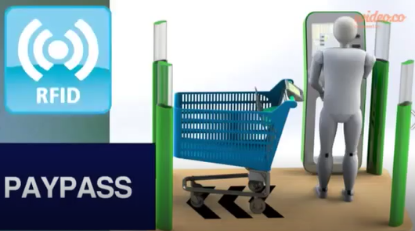

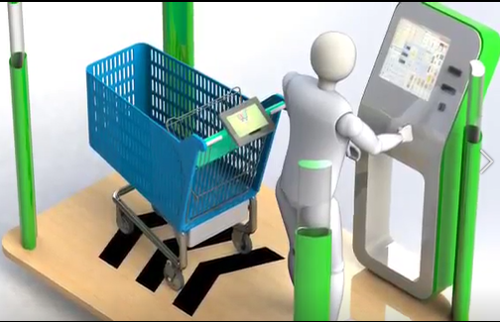

**(Figure 12- This is a Figure of iCart after completing shopping that RFID readers will scan the trolley and send the details to that machine. From this machine customer pay their payment by card.)**

**(Figure 13- This is a Figure of iCart after completing the shopping paying card payment)**

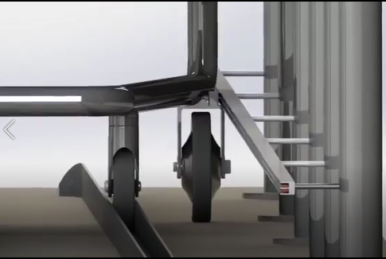

**Figure 15 - This is a Figure of iCart powered by charging through the wheel)**

**(Figure 14- This is a Figure of iCart powered by charging)**

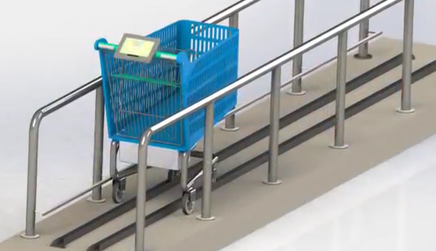(www.youtube.com/watch?v=40oH-dhtIK0&t=2s, n.d.)

### Critical Evolution (Compare, contrast and evaluate) of iCart smart shopping cart

iCart smart shopping cart is a company which introduces to market smart trolley. This smart trolley is an electric, comfortable, user friendly and can fast shopping. This smart trolley shopping speed is 252km/h, Autonomy is 8 hours and weight is 72kg. This base is made of Steel AISI 304 and basket is made of Polypropylene 30% Glass fibber. Powered by Electric motor, Wheel hub motor and FG-R-88. Power is 200W, Torque is 5,3Nm and 24-36 VDC/ 8” – 6”. There is a Drive and Control system. That will guide customer to turn right, turn left and go straight. This trollies use Battery system; they are Lead acid batteries and vision battery. This Autonomy is 8 hours, Voltage 24V/ Capacity 24 Ah and 576Wh. There is a charging system and after shopping there is a pay money method call Pay Pass.

We implemented only prototype for smart shopping trolley. We didn’t implemented like iCart smart shopping cart because this is for the business customization. But, in future we have idea to expand our smart shopping trolley like iCart smart shopping cart. In future we will develop this prototype in to like iCart smart shopping cart features of physical and quality. Also, we will develop our smart trolley with charging system and pay money method call Pay Pass.

iCart smart shopping cart has authenticate screen. There we have to type our username and password. Then, we will login to our account from screen. If we don’t have account we need to sign up. In our smart shopping trolley also has authenticate screen. From that customer can authenticate to their account. This authenticate screen in smart trolley in display is very much easy to use for customers and customers don’t need any other application to identify specific (unique) user.

In iCart smart shopping cart, has connected to a server computer. This will store every customer accounts and details. After that server computer will analyse our previous shopping and guide us what we have to buy through the screen. We also connected smart trolley with main computer to do above mentioned functions. This is very much easy to user to focus on the display only. Whatever messages when we reading meant we can easily remember than listening. So, we also used these features in our smart trolley.

In iCart smart shopping cart, after shopping customers can pay money from Pay Pass. There are two RFID readers in two sides. Then, trolley is middle. That trolley products will scan by RFID readers and that every information will send to that machine. From the card payment customers can pay their amount. In our smart trolley, instead of besides using RFID tags we are using it inside of our smart trolley. We didn’t use same like machine which get information of products inside of cart by RFID reader. Instead of that we use inside the trolley we are using RFID readers. Because it is very much easy to get total amount of product and details before we go to counter. But in iCart smart shopping cart again they have wait for that machine scan one cart after another by RFID readers. But, our main purpose is to reduce the queue waiting time. So, before, we go to counter the total purchase products details will send to counter at the same time customer get ready for money from his display total amount. This will increases customer satisfaction. In iCart smart shopping cart, that machine will pay the payment by card. In our smart trolley, payment can done by card payment in our main computer or manual. Because every customers not using cards.

In iCart smart shopping cart, **IOT** using way is **iCart screen** and **server computer** is connected via network. Sameway, we used IOT in our smart trolley. This is very much easy for customer to get guidance or AI support througt the network to display. this will increases customer satisfaction.

In iCart smart shopping cart, **IOT** using way iswhen every shopping complete that trolley is scan by both side RFID readers. From that every products details in trolley and total amount is send to that machine. **Machine** is connected to **bank**. customer must pay their payment throught the card. In our smart trolley instead of that machine we also use main computer. Our main computer also connected to bank. We can do card payment or manual payment. Because, we keep both options because of customer needs.

In iCart smart shopping cart, **AI** using way is Server computer has AI and that will analyse our previous shopping and guide us what we have to buy through the screen. We also use AI for our smart trolley. Because of above reasons. AI will assist and guide us through the display. AI analyse our previous data and it will give suggestions correct time. So, if we use AI in any field meant it will be success. So, we also use AI technology in our trolley.

Finally, for our smart trolley we got lots of idea from iCart smart shopping cart. In our project, some of the ideas we took and rest of ideas we omit according to our project requirements.

(Author’s view)

### AMAZON GO

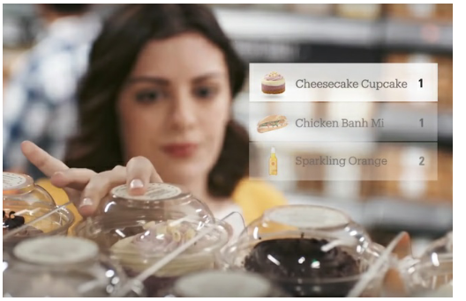When entering to amazon go supermarket that entrance is checking and verifying our QR code and permitting us. So, that QR is in a mobile application and we must have account in there. After that we can shopping well. When we pick up any things that will be automatically added to our virtual card. That shopping will update for our virtual card automatically. They used computer vision, deep learning algorithms, sensor fusion like just walk out technology. When we leaving the supermarket we don’t need to wait to pay money. Every items which we took they will update in our virtual card. And we can check it in our amazon go account in our mobile application. So, our payment done through our credit card. They used camera tracking system that also uses AI in the form of the facial recognition or user biometrics, as well as sensors. This is would work using a system of cameras, sensors and / or RFID readers to identify shoppers and their items.

**(Figure 16- This is a Figure of updates of virtual card)**

**QR code**- to the entrance unique QR code (Primary key) for every account (in mobile app)

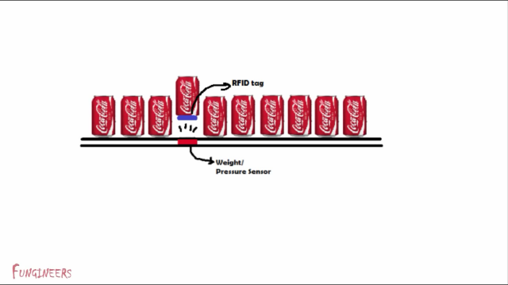**IOT**- Supermarket sensors and virtual card connected with network and exchanging information.

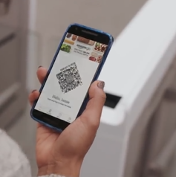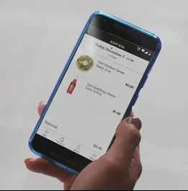**AI**- if we took anything that will be automatically updated. If we took any item and we kept it meant that will be also automatically updated. That buying items can be change by human to human. And finally AI conform we took that items or not. They use Deep learning algorithms, computer vision, sensor fusion, just walk out technology and facial recognition or user biometrics meant that must be an Artificial Intelligence.

**(Figure 17- This is a Figure of uses of weight sensors and RFID tag in shelves)**

**(Figure 19- This is a Figure of Mobile App with All the details of products which they bought)**

**(Figure 18- This is a Figure of QR for Amazon Supermarket Entrance)**

(www.youtube.com/watch?v=NrmMk1Myrxc&t=36s, n.d.)

### Critical Evolution (Compare, contrast and evaluate) of AMAZON GO

In AMAZON GO shopping store, when entering to amazon go supermarket that entrance is checking and verifying customer QR code and permitting them. So, that QR is in a mobile application and customer must have account in there. Instead of Mobile application QR code as unique identification; in our supermarket trolley we use authenticate screen in TFT 5” Display. Because AMAZON GO technology is very much demanded. We are using normal technology for our shopping trolley. Because of cost effective.

In AMAZON GO shopping store, after that customers can shopping well. When customer pick up any things that will be automatically added to their virtual card. That shopping will update for their virtual card automatically. They used computer vision, deep learning algorithms, sensor fusion like just walk out technology. In our supermarket trolley if we scan with RFID tags meant only products will add or remove. From this customers can do the theft easily. But, if we used like these technologies meant that will be tracking every customer actions that meant pick up any things and after that keeping the things every actions updating in virtual cards. So, customer can’t be do theft. For every those actions they have video proofs. We are not using these AMAZON GO full demanded AI and IOT based technology. Because of cost effective and time effective. In AMAZON GO virtual card in mobile application. In our supermarket trolley our virtual card is in TFT 5” Display and counter computer. Because we didn’t develop AI and connect with mobile application. Because of lack of time.

In AMAZON GO shopping store, when we leaving the supermarket we don’t need to wait to pay money. Every items which we took they will update in our virtual card. And we can check it in our amazon go account in our mobile application. So, our payment done through our credit card. In our supermarket trolley, we need to wait to pay money or card payment. But, waiting time will reduce. Because, before trolley come counter, trolley SD card and counter computer is connected with each other by Wi-Fi. So, trolley SD card transfer all the purchasing products details before come to counter computer. So, queue waiting time will reduce for customer. So, we can pay the payment by money or card payment. In our supermarket trolley, card payment meant our payment done by counter computer. But in AMAZON GO it will done by customer already has enter their card details. So, they reduce money from their account using mobile application. Because, we did not use this system because all the customers don’t like to do online payments.

In AMAZON GO shopping store, they used camera tracking system that also uses AI in the form of the facial recognition or user biometrics, as well as sensors. This is would work using a system of cameras, sensors and / or RFID readers to identify shoppers and their items. In our supermarket trolley, we used AI in main computer and guiding the customers through the displaying the messages in TFT 5” Display. Our main focus of this project is to get customer satisfaction through the assisting by AI. But, in AMAZON GO they are not guiding the customers. They are mainly focus on security and latest trend of business. We also using sensors and / or RFID readers to identify purchasing items. Because it is latest trend for identification.

In AMAZON GO shopping store, using **IOT** using way is Supermarket **sensors** and **virtual card** connected with network and exchanging information. Almost every devices connected with each other and take decisions analysing those devices taking data by AI. In our supermarket trolley, we also used same this technology**. Products shelves sensor** is connected to trolley **TFT 5” Display** through the Wi- Fi network. Again **TFT 5” Display** is connected with **counter computer** through the Wi- Fi network. Again, **TFT 5” Display** is connected with **main computer** to authenticate through the Wi-Fi.

In AMAZON GO shopping store, **AI** using way is when we took any products meant that will be automatically updated. If we took any item and we kept it meant that will be also automatically updated. That buying items can be change by human to human. And finally AI conform we took that items or not. They use Deep learning algorithms, computer vision, sensor fusion, just walk out technology and facial recognition or user biometrics meant that must be an Artificial Intelligence. In our supermarket trolley, we are not those high level AI technology. Because it will take long period to practise and expenditure will be high cost in AI. Our main target is guiding the customer through the pop up messages in the TFT 5” Display. We are using AI in main computer. That will guide the customers by previous customer data.

Finally, for our smart trolley we got lots of idea from AMAZON GO shopping store. Because, AMAZON GO is the best ranked AI using Business organization. So, for our project, some of the ideas we took and rest of ideas we omit according to our project requirements

(Author’s view)

### indolytics technology

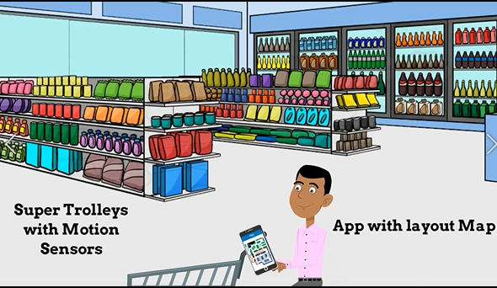indolytics technology provides mobile application, super trolley and main server computer. Main server computer which gives all activities happening in the store and giving the admin to all the control. This is work like this. The customer walks in. pick up a super trolley. The trolley is always with motion sensors. Using their mobile app customer will navigate the products which they have to buy. Main server computer keep tracks through the trolley’s motion sensors. Where customer will go, how long customer will stop and which section customer buy from and quae wait time at the payment time. This main computer can control the Contextual discount as a customer crosses varies sections. This main server can actually track all the activities using with digital and cloud based interactive map.

**(Figure 20- This is a Figure of super trolley and Mobile app with layout Map)**

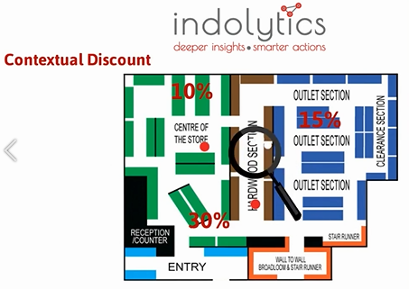

**IOT-** indolytics technology provides mobile application, super trolley and main server computer. So, these are connect each other in cloud base.

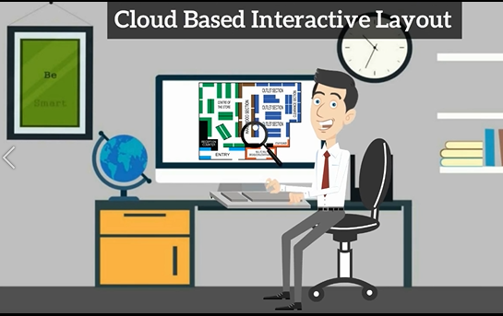

**(Figure 21- This is a Figure of server computer guides that trolley cross the products in various section according to discount Products)**

**(Figure 22- This is a Figure of server computer tracks all the activities happening in the supermarket)**

(www.youtube.com/watch?v=psPg3cgQYdc&t=22s, n.d.)

### Critical Evolution (Compare, contrast and evaluate) of indolytics technology

In indolytics technology, provides mobile application, super trolley and main server computer. Main server computer which gives all activities happening in the store and giving the admin to all the control. In our supermarket trolley, needs smart trolley with TFT 5” Display, products shelves sensors and main computer. We didn’t use mobile application. Because we included all the functionalities in here which done by mobile application in to TFT 5” Display. They are not using displays. They use only smart trolley.

In indolytics technology, work like this. The customer walks in. pick up a super trolley. The trolley is always with motion sensors. Using their mobile app customer will navigate the products which they have to buy. Main server computer keep tracks through the trolley’s motion sensors. Where customer will go, how long customer will stop and which section customer buy from and queue wait time at the payment time. This main computer can control the Contextual discount as a customer crosses varies sections. This main server can actually track all the activities using with digital and cloud based interactive map.

In our supermarket trolley, we are not using motion sensors and identify the place where trolley move by tracking. Because we are using TFT 5” Display (SD card) and products shelves sensors are connected with each other with Wi-Fi. Then, when we cross the discount products shelves; products shelves sensors will send the data to TFT 5” Display (SD card). Then, discount messages will pop up to the display. We use this IOT technology because that is very much demanded technology in every fields. Specially in business. So, for our project this IOT is best than server computer tracking by motion sensors and giving the alerts to customers.

In our supermarket trolley, we are not tracking customers through the motion sensors by server (main computer). Tracking meant where customer will go, how long customer will stop and which section customer buy from and queue wait time at the payment time, Track all the activities using with digital and cloud based interactive map. Our supermarket trolley target is to reduce the queue waiting time by transfer data before reach counter and guiding the customers through the network. So, indolytics technology get data about products details of customers by tracking. We get data of products by scanning RFID tags in to RFID readers. And transfer it in to main computer. In main computer AI has developed. So, that will take those customer data and analysing it. Whenever need it will guides pop up messages in display through the Wi-Fi network. We are not using digital and cloud based interactive map. Because of our basic requirements of our smart trolley. So, we are focusing AI based smart trolley.

In indolytics technology, using **IOT** is; this technology provides mobile application, super trolley and main server computer. So, these are connect each other in cloud base. In our supermarket trolley also using IOT by smart trolley with TFT 5” Display with products shelves, TFT 5” Display with sensors and TFT 5” Display with main computer. We didn’t use mobile application because as mentioned earlier we covered all the functionalities done by it. By using TFT 5” Display.

If indolytics technology uses AI in Main computer meant if we code for AI I for these functionalities such as that will automatically tracks through the trolley’s motion sensors. Where customer will go, how long customer will stop and which section customer buy from and quae wait time at the payment time, can control the Contextual discount as a customer crosses varies sections and track all the activities using with digital and cloud based interactive map. From these data AI will analyse the customer data and give best solutions and suggestions for each customer. No need person to track and maintain the trolley movements. Through that analysed data AI can give voice guidance or display assist to customers. So, from in this process customers and business organization will get benefit. So, from AI use; Customer satisfaction will increase.

Finally, for our smart trolley we got lots of idea from indolytics technology. In our project, some of the ideas we took and rest of ideas we omit according to our project requirements.

(Author’s view)

### Modern-Expo Group (Self-Checkout on the Go (Smart Shopping Cart))

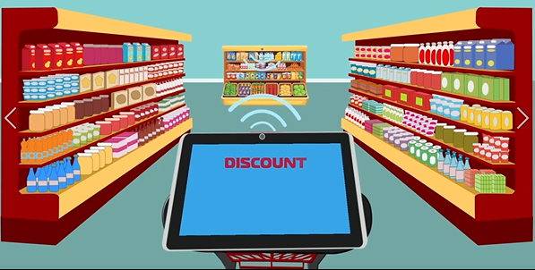This is a smart trolley. This has one screen. That screen displays main details of products and navigate the products. Every shelves there have sensors. That sensors will send products discount by network. When smart trolley go near to those sensor; trolley screen and those sensors will connect each other by network. So, that sensors sends discount products details and that screen will display those information.

**(Figure 23- This is a Figure of Screen of Smart trolley is connecting with shelf sensors by go near shelves)**

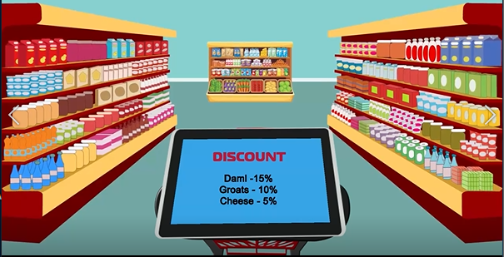This screen is connected to mobile app also from the network. So, this mobile application will remind what the products we have to buy. Then, that screen navigate those products places. In trolley there is a reader of products. Then, if we add any products that will scan and sends the details to screen. The details are product image, quantity, cost and total price. So, finally screen will show whole products total price with those details and after that when we go near to counter that products details will send to counter computer by network before we reach the counter.

**IOT-** This Screen Connected to shelves sensors by network. Mobile App will remind customers to products which they have to buy. According to those products Screen of Cart will navigate products places. After shopping before customer reach the counter Screen will send all the products and total to counter computer. This is also connected with network.

**(Figure 24- This is a Figure of Screen of Smart trolley which displays all the discount products in nearest shelves)**

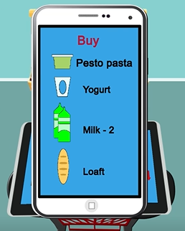**AI-** Mobile Application Analyse what we always buying products and remembering the products.

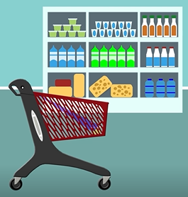

**(Figure 25- This is a Figure of Mobile app remembering the products)**

**(Figure 26- This is a Figure of trolley which scans the products when we adding to trolley)**

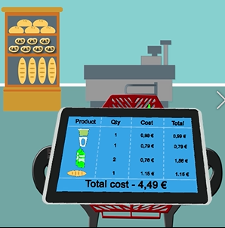

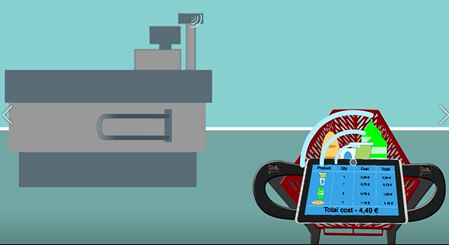

**(Figure 27- This is a Figure of trolley screen which displays products details which we add to trolley)**

**(Figure 28- This is a Figure of trolley screen connected to counter computer through the network. That will send the product details before trolley reach to counter)**

(www.youtube.com/watch?v=VaVRTBB2LVM&t=6s, n.d.)

### Critical Evolution (Compare, contrast and evaluate) of Modern-Expo Group (Self-Checkout on the Go) Smart Shopping Cart

In Modern-Expo Group (Self-Checkout on the Go) Smart Shopping Cart, Every shelves there have sensors. That sensors will send products discount by network. When smart trolley go near to those sensor; trolley screen and those sensors will connect each other by network. So, that sensors sends discount products details and that screen will display those information. In our smart trolley, we are also using same that technology. Because our main target is shopping has to be easy for customers through this smart trolley. From this, customers will feel satisfaction in this shopping.

In Modern-Expo Group (Self-Checkout on the Go) Smart Shopping Cart, screen is connected to mobile app also from the network. So, this mobile application will remind what the products we have to buy. Then, that screen navigate those products places. In our smart trolley, we did not use mobile application. Because we are covering mobile app functionalities which they use for that project by screen in our smart trolley. We cover our smart trolley, reminder part appear by screen (TFT 5” Display). So, no need of another application. Customer authenticate also done by screen (TFT 5” Display).

In Modern-Expo Group (Self-Checkout on the Go) Smart Shopping Cart, in trolley there is a reader of products. Then, if we add any products that will scan and sends the details to screen. The details are product image, quantity, cost and total price. So, finally screen will show whole products total price with those details and after that when we go near to counter that products details will send to counter computer by network before we reach the counter. In our smart trolley, we also using same like that. Because, our main target of smart trolley is save the customer time and queue waiting time. Increase the customer satisfaction in organization. From that, these targets will cover.

In Modern-Expo Group (Self-Checkout on the Go) Smart Shopping Cart, using **IOT** way is **Screen** Connected to **shelves sensors** by network. **Mobile App** will remind customers to products which they have to buy. According to those products **Screen of Cart** will navigate products places. After shopping before customer reach the counter **Screen of Cart** will send all the products and total to **counter computer**. This is also connected with network. In our smart trolley, we are also using same like that. Because, to increase customer satisfaction. But, we are not using mobile app. Because as mentioned earlier, we covered all the Instead of that we are using **Screen of trolley (TFT 5” Display)** is connected **to main computer**.

In Modern-Expo Group (Self-Checkout on the Go) Smart Shopping Cart, using **AI** way isMobile Application Analyse what we always buying products and remembering the products in Mobile Application. In our smart trolley, we are not using **AI** inMobile Application. Because, we are focusing in our project AI based in main computer in business organization. Then, it is easy to authenticate in trolley screen. It is increasing customer satisfaction. AI is in main computer. AI is Analyse what we always buying products and remembering the products and transfer to screen of trolley **(TFT 5” Display)**. Then, screen will pop up messages through the network.

Finally, for our smart trolley we got lots of idea from Modern-Expo Group (Self-Checkout on the Go) Smart Shopping Cart. In our project, some of the ideas we took and rest of ideas we omit according to our project requirements.

(Author’s view)

### Flavio Bernardo

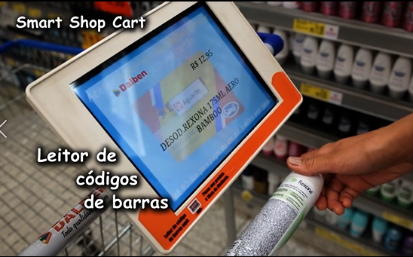This company also introducing smart trolley for supermarkets. So, this trolley has large display. So, in this display we can see all the information about discount products and scanning products. There is a barcode reader side of screen. So, we can scan products by barcode from barcode reader. Then, we can see in the display all the main information about products and we can add in to trolley. Every each shelf has sensors to inform about products discounts. It sends the discount products details through the network. When the trolley is near to that sensors that display will automatically get the information about discount products and display in the screen. So, they will get alert from those sensors.

**(Figure 29- This is a Figure of Trolley Screen scanning the products from barcode of products)**

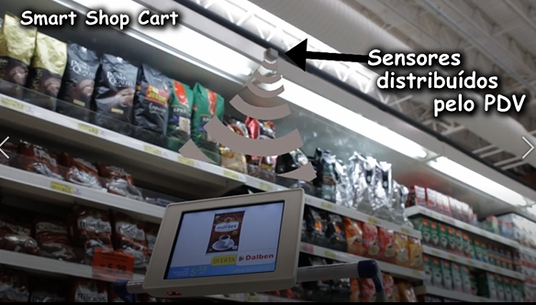**IOT-** Sensors in shelves and trolley screen connected and share information about discount by network.

**(Figure 30- This is a Figure of Trolley Screen get signal from sensors about discount product when trolley goes near to shelf)**

(www.youtube.com/watch?v=OeSqnLZXKM4&t=4s, n.d.)

### Critical Evolution (Compare, contrast and evaluate) of Flavio Bernado trolley

In Flavio Bernado trolley, has large display. So, in this display we can see all the information about discount products and scanning products. There is a barcode reader side of screen. So, we can scan products by barcode from barcode reader. Then, we can see in the display all the main information about products and we can add in to trolley. In our smart trolley, we are also using large screen. Because in our smart trolley many functionalities done by screen of trolley. Such as authenticate function, when products scanning products details, alerts and reminders done by AI in main computer and transfer it to screen, when customer crossing products shelves, shelves sensors sends discount products details to screen and etc. we didn’t use barcode reader. Instead of that we are using RFID readers. Because, RFID readers are latest trend in business organization. Our RFID readers are inside of trolley because, this can detect the products easily.

When we are using Flavio Bernado trolley meant every each shelf has sensors to inform about products discounts. It sends the discount products details through the network. When the trolley is near to that sensors that display will automatically get the information about discount products and display in the screen. So, they will get alert from those sensors. In our smart trolley, we are also using same that. Because, this project target is reducing customer time in supermarket and do the shopping with user friendly way. So, from this technology customer satisfaction is increasing.

In Flavio Bernado trolley, **IOT** using way isSensors and trolley screen connected and share information about discount by network. In our smart trolley, we are also using this kind of IOT. Because, IOT is very much demanded technology. If we implement any projects using IOT meant that will be very much success. Mainly, if we using IOT in business field meant that will be best successful.

If Flavio Bernado trolley, use AI meant for their trolley meant that can be more success. Because, this AI involves trolley that can perform tasks that are characteristic of human intelligence. From that, they can increase understanding of the customer / target customer, Segmentation, learning from user behaviour and on-site data, Predicting customer preferences which meant seek to show relevant products at the right time and using previous data algorithms can predict customer preferences. So, from these data AI will assist customer in the whole shopping process. Through that customer satisfaction will increase. So, we can cover our main aim in here.

Finally, for our smart trolley we got lots of idea from Flavio Bernado trolley. If they use AI for their trolley meant that will be more success. In our project, some of the ideas we took and rest of ideas we omit according to our project requirements.

(Author’s view)

### Grocer Augmented Shopping (European Project)

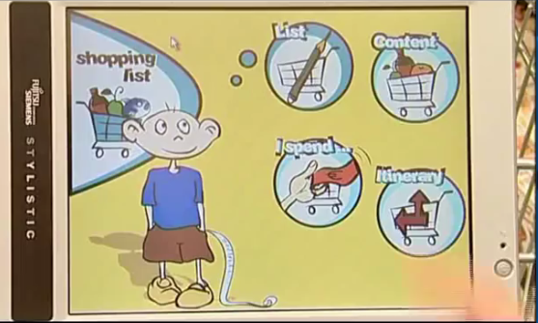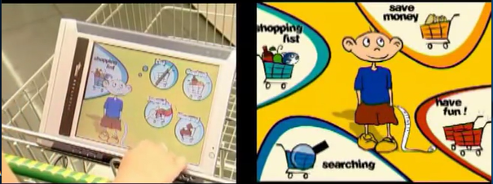In here they use smart trolley. In this trolley there is a touch large screen in the trolley. When customer enter to the supermarket that customer will register with the system and identify themself. System will use to store data with the complete personal service to enjoy the all the benefits of user. When customer start the shopping; trolley screen will show main menu which contains shopping list, save money, have fun and searching. In shopping list service artificial intelligence software will use to help customers in their shopping. In there is list. It reminding products which user forget to buy by analysing the last shopping’s. In content contain basic products list. That will store every time customer consume products list. Customer can add or delete any products in that list. So, that will store in database. In Ispend customers can know what products are in trolley and how much they have to spend for that. Then they can know expenditure of money. Itinary is a three dimensional map. This will guide the customer the shortest way/ distance to reach the selective product.

**(Figure 31- This is a Figure of** **main menu in trolley screen which contains shopping list, save money, have fun and searching)**

**(Figure 32- This is a Figure of** **submenu of shopping list in trolley screen which contains list, content, Ispend and Itinary)**

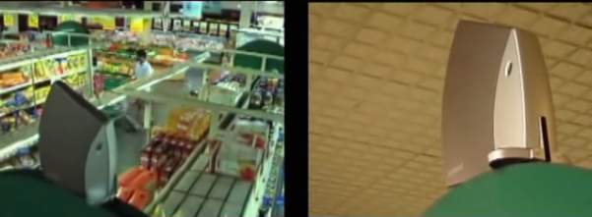This technology Allows to system to localized the customer details and send them information every movement. This is based localization technology and intelligent software send to the system personalized messages at the right time and right customer. Save money service allows the customer offers, promotions and points in interactive ways. This will pop up messages near to offer or discount products. Or in icons colours of those icons will change. Privacy protected by customer preferences. In searching we can see all the information and ingredients of which we selecting product by scan the barcode reader.

**(Figure 33- This is a Figure of sensor technology this will send to the system personalized messages at the right time and right customer)**

**IOT-** trolley screen, main computer which customer data stored and sensors are connected with each other in a network and communicate and share information via network. Customer can track their friend’s location inside the supermarket and they can chat with each other in text massages. So, this is also act like communication device via network.

**AI-** every customer has account in main computer. The computer uses AI to remember the product list from previous analysing shopping. Then, Show the shortest way route to reach those products. That analysing all expenditures and comparing then shopping and reminding. Every each user points and promotions are different. That Computer those data and give correct amount of them to each customers.

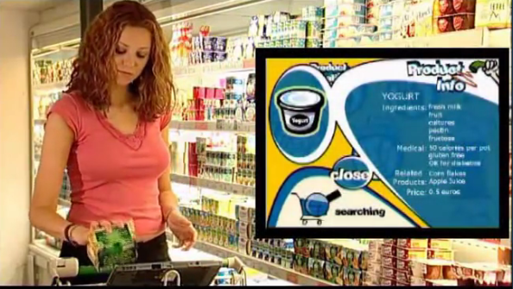

**(Figure 34- This is a Figure of trolley screen product information by customer scan that product barcode to barcode reader)**

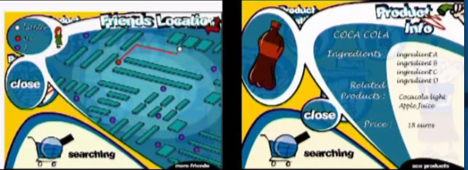

**(Figure 35- This is a Figure of** **submenu of Searching in trolley screen which includes friends’ location searching in supermarket and search products details by scanning)**

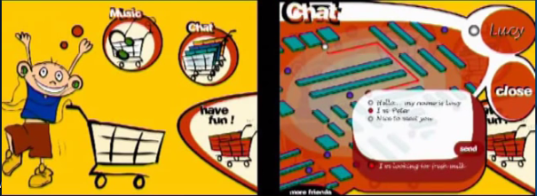

**(Figure 36- This is a Figure of** **submenu of Have fun in trolley screen which includes chat with supermarket friends and can hear the music)**

**(Figure 37- This is a Figure of** **submenu of Searching in trolley screen which includes friend’s location, Menu suggestions, Product info and product location)**

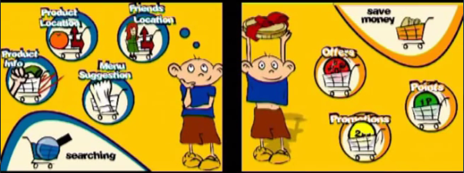

**(Figure 38- This is a Figure of** **submenu of save money in trolley screen which includes offers, promotions and points)**



(www.youtube.com/watch?v=KdT4miCTbds, n.d.)

### Critical Evolution (Compare, contrast and evaluate) of Grocer Augmented Shopping trolley

In Grocer Augmented Shopping trolley, has is a touch large screen in the trolley. When customer enter to the supermarket that customer will register with the system and identify themself. System will use to store data with the complete personal service to enjoy the all the benefits of user. In our smart trolley, we didn’t use touch screen. Because of cost effective.

In Grocer Augmented Shopping trolley, work like this; when customer start the shopping; trolley screen will show main menu which contains shopping list, save money, have fun and searching. In shopping list service artificial intelligence software will use to help customers in their shopping. In there is list. It reminding products which user forget to buy by analysing the last shopping’s. In content contain basic products list. That will store every time customer consume products list. Customer can add or delete any products in that list. So, that will store in database. In Ispend customers can know what products are in trolley and how much they have to spend for that. Then they can know expenditure of money. Itinary is a three dimensional map. This will guide the customer the shortest way/ distance to reach the selective product.

In our smart trolley, we did not include main menu and submenus like Grocer Augmented Shopping trolley. Because our smart trolley targets that meant we are targeting some of functionalities in trolley screen. They are, authenticate function, when products scanning products details, alerts and reminders done by AI in main computer and transfer it to screen, when customer crossing products shelves, shelves sensors sends discount products details to screen and etc. also, we taking normal screen (Display). Not touch screen (Display). So, selection of submenus are hard in our displays. Our AI in main computer send messages to screen through the network. Then, trolley screen pop up messages about reminding products which user forget to buy by analysing the last shopping’s. We don’t have submenu like In Grocer Augmented shopping trolley. But, we focusing this project in low cost. But, we have too many features whenever we need messages will pop up in the display. We didn’t focus products navigation that meant three dimensional map. Because, our smart trolley is covering basic requirements. We have ideas to expand our trolley features in to Grocer Augmented Shopping trolley.

In Grocer Augmented Shopping trolley, this technology Allows to system to localized the customer details and send them information every movement. This is based localization technology and intelligent software send to the system personalized messages at the right time and right customer. In our smart trolley, we also using these features. Because this will increases customer satisfaction in business organization.

In Grocer Augmented Shopping trolley, save money service allows the customer offers, promotions and points in interactive ways. This will pop up messages near to offer or discount products. Or in icons colours of those icons will change. Privacy protected by customer preferences. In searching we can see all the information and ingredients of which we selecting product by scan the barcode reader. In our smart trolley, we are not using main menu and submenu to divide our trolley functionalities. Because if we include more divided functionalities meant it will get more cost effective and time effective. Then, we have use very large and touch display. Again, it will increase expenditure. But, we also included functionalities of those submenu in Grocer Augmented Shopping trolley. But, we use that functionalities without any divide whenever customer need time. So, we are also including those functionalities to increase customer satisfaction and take business organization in to leading position with compare with competitors. In future we have expand our mart trolley in to menu and submenu. Then, we will have ideas to categorize functionalities and access in the sub menu.

In Grocer Augmented Shopping trolley, using **IOT** like this.Trolley screen, main computer which customer data stored and sensors are connected with each other in a network and communicate and share information via network. In our smart trolley we are also using same like this. Because, to increase the customer satisfaction.

In Grocer Augmented Shopping trolley, Customer can track their friend’s location inside the supermarket and they can chat with each other in text massages. So, this is also act like communication device via network. In our smart trolley, we are not using like this. Because if we consider massaging facility and friends’ location tracking meant that we need more cost and time. In future we have ideas to develop these feature to our smart trolley.

In Grocer Augmented Shopping trolley, using **AI** like this.Every customer has account in main computer. The computer uses AI to remember the product list from previous analysing shopping. Then, Show the shortest way route to reach those products. That analysing all expenditures and comparing then shopping and reminding. Every each user points and promotions are different. That Computer those data and give correct amount of them to each customers. If we take our smart trolley, we are also using same these AI functionalities. Because, these will increase customer satisfaction and reduce wasting time in super market. But, when we consider some of messaging and fun stuff we didn’t included. Otherwise, most of functionalities are included. But, from the screen access these AI functionalities are categorized in Grocer Augmented Shopping trolley. In our smart trolley, we are accessing those functionalities whenever we need by AI.

Finally, for our smart trolley we got lots of idea from Grocer Augmented Shopping trolley. This project, some of the ideas we took and rest of ideas we omit according to our project requirements.

(Author’s view)

## Research approach and methodologies

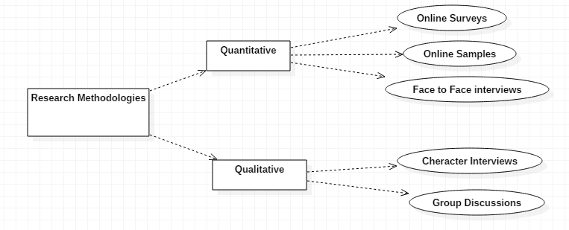

**(Figure 39- This is a Figure of some of** **methodologies of research)**

### Quantitative research methods

Quantitative Research is used to quantify the problem by using way of producing numerical data or records that can be changed into usable statistics. It is used to quantify attitudes, opinions, behaviours, and different defined variables and generalize consequences from a large pattern population. Quantitative Research uses measurable records to formulate statistics and uncover patterns in research. Quantitative statistics series methods are a lot more structured than Qualitative facts collection methods. In here we can divide it in three ways. They are online surveys, online samples and ace to face interviews. But, in this project I used three methodologies in quantitative research methodologies. They are online surveys, online samples and face to face interviews. In online samples meant we get the information from internet. So I collect lots of information of this project from internet, YouTube. From Internet meant use of personal records, data analysis and action research. Face to face interview for this project is I Interviewed our lecturer and got lots of ideas for this projects and got ideas from seniors also. For online surveys I used Google forms and got 260 responses from people which I know well. So, I will detailed below about online surveys (Author’s view).

#### Online surveys

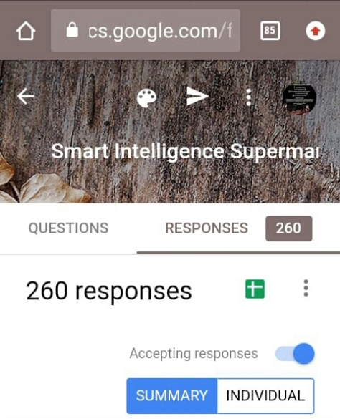I created online surveys in Google form and got two hundred sixty responses (260). From this I can get some decisions for my project.

**(Figure 40- This is a Figure of online Google form responses which I got from people I known for my Project)**

First question which I asked in my questionnaire is about status of shopping period in supermarket from people which I known.

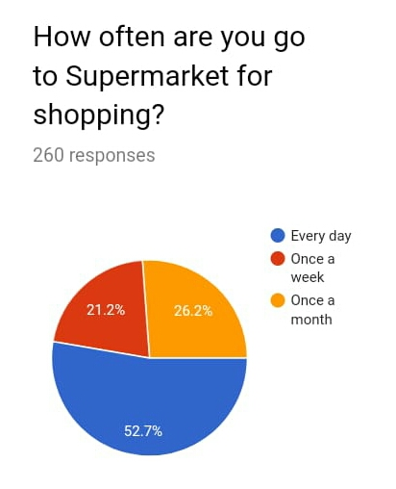From these two hundred sixty responses (260) fifty two point seven percentage of people go to shopping every day. Twenty six point two percentage of people go to shopping once a month. Twenty one point two percentage of people go to shopping once a week. So, from this information we can get main decision which is this era is changing Supermarket Shopping is main need for every people. So, if we focus any projects related to supermarket mostly that will be success.

**(Figure 41- This is a Figure of online Google form responses which for percentage status of supermarket shopping)**

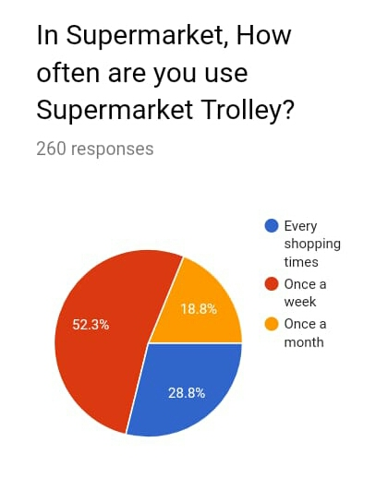From those people the status of people percentage which they use supermarket trolley or shopping. Fifty two point three percentage use once a week supermarket trolley. Twenty eight point eight percentage use supermarket trolley in every shopping times. Eighteen point eight percentage use supermarket trolley in once a month. From these information most of people are every day shopping. Among them most of them use shopping trolley once a week. Quarter percentage use shopping trolley every shopping times.

**(Figure 42- This is a Figure of online Google form responses which is percentage status for usage of supermarket Trolley)**

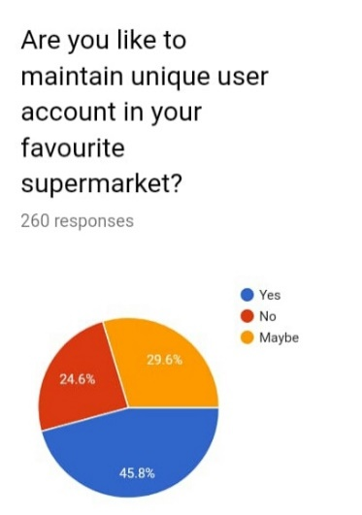From these people forty five point eight percentage will surely prefer to maintain unique user account in favorite supermarket. Twenty nine point six parentage people not sure to maintain unique account in supermarket. Twenty four point six parentage people not interested in unique account in supermarket. From this information almost everyone like to maintain unique user account in supermarket. From this we can connect trolley screen to user account and get previous details of shopping through that we can get guidance for shopping.

**(Figure 43- This is a Figure of online Google form responses which is percentage status of preference to maintain unique account in supermarket)**

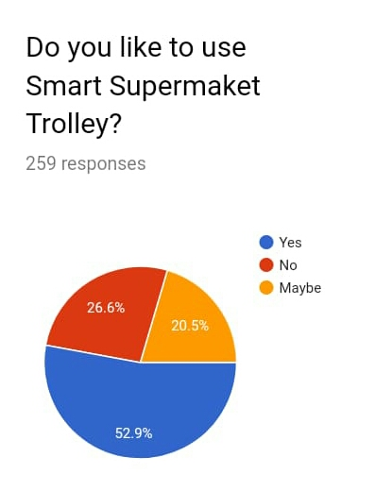

Fifty two point nine percentage like to use smart supermarket trolley. Twenty six point six percentage not like to use smart supermarket trolley. Twenty point five percentage no sure idea to use smart supermarket trolley. Among these almost everyone like to use smart supermarket trolley. So, from this information our project has demand and it can be almost success in market.

**(Figure 44- This is a Figure of online Google form responses which is percentage status of preference to use smart supermarket trolley)**

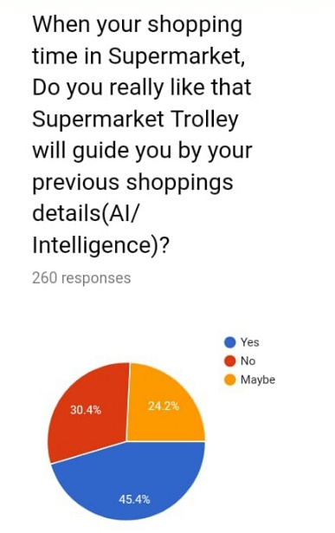

Forty five point four percentage will prefer to use supermarket trolley which will guide customer by their previous shopping details. That meant using Artificial Intelligence (AI). Thirty point four percentage not prefer to use supermarket trolley and twenty four point two percentage no sure idea to use supermarket trolley which will guide customer by their previous shopping details. Among these people Almost everyone interested to use AI. From these Information if we include AI in our project meant that will be most successful.

**(Figure 45- This is a Figure of online Google form responses which is percentage status of preference to use AI for smart supermarket trolley)**

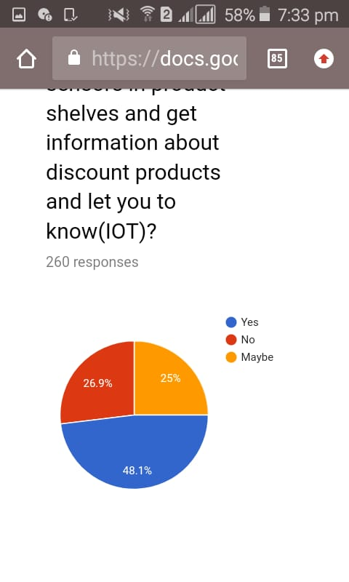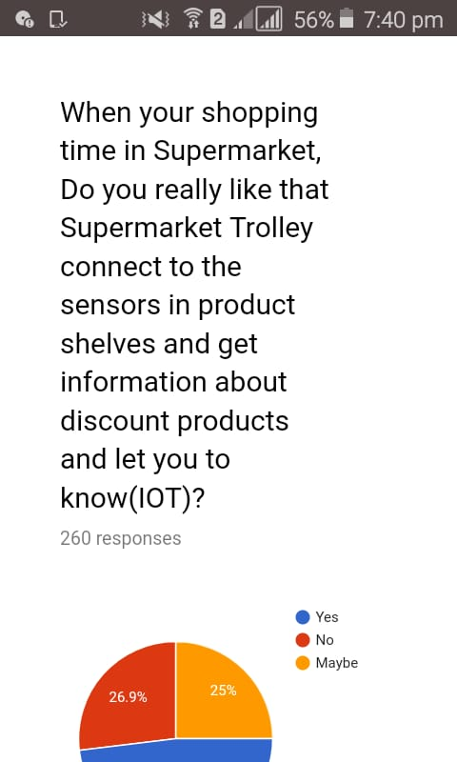Forty eight point one percentage prefer to use supermarket trolley that connect to sensors in product shelves and get information about discount products and let customer to know. That meant trolley and those sensors connect with network. So, that is call as IOT. Twenty six point nine percentage not prefer to use IOT. Twenty five percentage no sure idea to use IOT. From these information almost everyone interested to use IOT. So, in my project also I will include IOT.

**(Figure 46- This is a Figure is a question which is to know percentage of prefer to use IOT)**

**(Figure 47- This is a Figure of online Google form responses which is percentage status of preference to use IOT for smart supermarket trolley)**

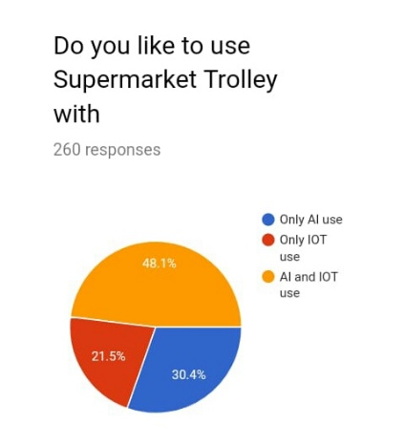Forty eight point one percentage prefer to use supermarket trolley with AI and IOT. Thirty point four percentage prefer to use Only AI only. Twenty one point five percentage prefer to use supermarket trolley with IOT only. Most of them prefer to have AI and IOT based Supermarket Trolley. So, In my project also I will do AI and IOT based Supermarket Trolley.

**(Figure 48- This is a Figure of online Google form responses which is percentage status of preference to use IOT and AI for smart supermarket trolley)**

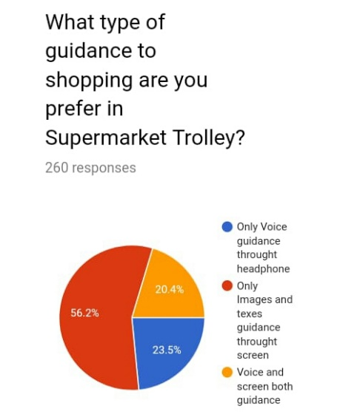Fifty six point two percentage will prefer to use Supermarket Trolley with images and texts through the screen guidance only. Twenty three point three percentage prefer to use Supermarket Trolley voice guidance through the headphone. Twenty point four percentage to use Supermarket Trolley with screen and voice both guidance. If we use voice system to guidance meant that will be sound effect for supermarket environment and hard to remember those details through voice but if we use screen we can see guidance from screen then we can easily remember those information. Supermarket environment also no hassle. In here most of them prefer to use screen guidance. So, we also use screen guidance to our project.

**(Figure 49- This is a Figure of online Google form responses for Voice and screen guidance for smart supermarket trolley)**

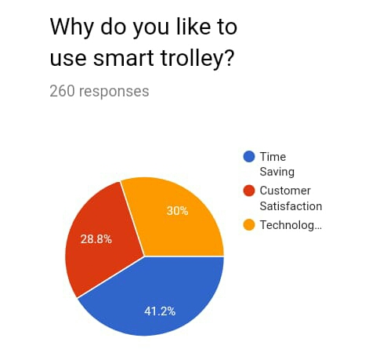Forty one point two percentage prefer to use smart trolley for time saving purpose. Thirty percentage prefer to use smart trolley for technological use. Twenty eight point eight percentage prefer to use smart trolley for customer satisfaction purpose. Almost, everyone prefer to use this trolley for time saving purpose.

**(Figure 50- This is a Figure of online Google form responses for reasons of prefer to use smart supermarket trolley)**

**(Author’s view)**

### Qualitative research methods

Qualitative Research is exceptionally investigative research. It is used to obtain an understanding of underlying reasons, opinions, and motivations. It affords insights into the trouble or helps to advance thoughts or hypotheses for manageable quantitative research. Qualitative Research is additionally used to discover traits in notion and opinions, and dive deeper into the problem. Qualitative information series methods change using unstructured or semi-structured techniques. Some common techniques include focal point organizations (group discussions), character interviews, and participation/observations. I choose character interview as qualitative methodology. I selected one person know about smart trolley and I interviewed him. Again, for this also I interviewed Mr. Anis Saboordeen lecturer of this project and got lots of ideas.

Finally, in this smart intelligent trolley project we used Camera Rpi high quality. Which meant Huhushop (TM) Camera. This module is compatible with all the models of Raspberry Pi. It is a 5MP camera and the video resolution amounts to 1080p, 720p. It has a 15 pin MIPI camera serial interface. Quality of our project very high. Which meant success at the same time sensors and devices which we used is also good and the output also very much success which we expected. Our IOT devices also worked properly. AI also did its work correctly. That meant, reminding products and giving alerts whenever need. So, our project is a successful project. So, quality is high (Author’s view).

## 4.4 Full details of the Artefact

There is a large screen on the top of trolley. When customer enter to supermarket then, they just login to the system via screen. Every products have RFID tags. If we add any products to the trolley those products detect by RFID readers and send the details of products to display. Such as image and the name of products, price of products, quantity of products and total price of products. Every products which we add for purchase whole details should display in the screen. We will use Power Adapter to power supply (Author’s view).

There are shelves with sensors. This is send information about that shelf contain discount products. When we are crossing those shelves those sensors connected with our trolley screen via network. So, those information of discount products will get as pop up messages in the trolley screen. When we are selecting the products which for buy we can know exact price of those products. And we can reduce our shopping expenditure. In here this system is run in main computer. That computer stores every each customer data. There is a counter computer in supermarket. After finish our shopping; trolley screen will sends the information about products details of purchase before we reaches the counter. So, counter computer and our screen is connected with each other in network. Then, we don’t need to wait for queue. We know about our total price before the cashier knows the total price. So, we can easily ready our payment by card or money (Author’s view).

### 4.4.1 IOT using way in our Smart Trolley

Our smart trolley **TFT 5” Display** and **main computer** is connected through Wi-Fi. Then, share the customer and products information. **Shelves sensors** and **TFT 5” Display** is connected with each other through Wi-Fi. When we are crossing the shelves sensor are sending alerts about products discount information. After, finish customer shopping before he or she reaches the counter; counter computer will get products details with prices which customer bought. Then, we can reduce queue waiting time in counter. Every customer looking this facility most. In here **counter computer** and **TFT 5” Display** is connected with each other through Wi-Fi. So, as our main requirement is to reduce customer waiting time in queue and to guiding the customer in the supermarket. So, in our smart trolley we are using IOT in three ways (Author’s view).

### 4.4.2 AI using way in our Smart Trolley

Artificial intelligence is the idea of using technology that behaves like a human, while machine learning algorithms are about finding patterns within data. While numerous industries in the world that have included artificial intelligence (AI). So, we used this AI for Business field. AI would therefore, observe its environment and take certain actions which will help optimize its success at a given objective. It is the simulation of human intelligence processes carried out by machines, especially computers. These could be learning, reasoning, analysing and so on.

AI is pretty much personal assistant. So, we used AI for Personal Assistant to guide our customers. This intelligent systems which have been taught to carry out specific tasks, based on data and information they collect from different sources. This type of machine learning can be output in the speech and language recognition. So, we output these guidance to customers by language messages popup in display. This AI can reasonably predict that more and more AI will be used to create multi-layer data on every customer, based on his/her past and current buying behaviour, and almost accurate prediction of future behaviour. These self-learning algorithms enable the machines to learn from data sets and can have various applications which can help customers and retailers alike. AI will analyse the data and guide to customers through the messages in the display.

These Algorithms are used in several ways:

* To increase understanding of the customer / target customer.
* Segmentation, learning from user behaviour and on-site data.
* Predicting customer preferences. Which meant, Recommendation engines, which seek to show relevant products at the right time.
* Predicting customer intent. Using data such as previous add to cart behaviour, algorithms can predict customer intent.

From these ways AI will analyse the customer data and giving the suggestions and predictions to our customers. When we are shopping time system will analyse last shopping’s and remembering the products which we like to buy. If the products is expiry meant system will inform us. If the customer is male meant if he select any item from female or baby that will inform to customer. Analyse the previous shopping’s budget and remembering the budget if the budget is overrun meant. When customer shopping time system will send the special offer, discounts and points messages. Then, screen will navigate those products places. That system will inform upcoming products which customer like and purchasing most. So, these information will display on display.

We did our AI coding in TensorFlow platform. TensorFlow is an end-to-end open source platform for machine learning. It has a comprehensive, flexible ecosystem of tools, libraries and community resources that lets researchers push the state-of-the-art in ML and developers easily build and deploy ML powered applications.

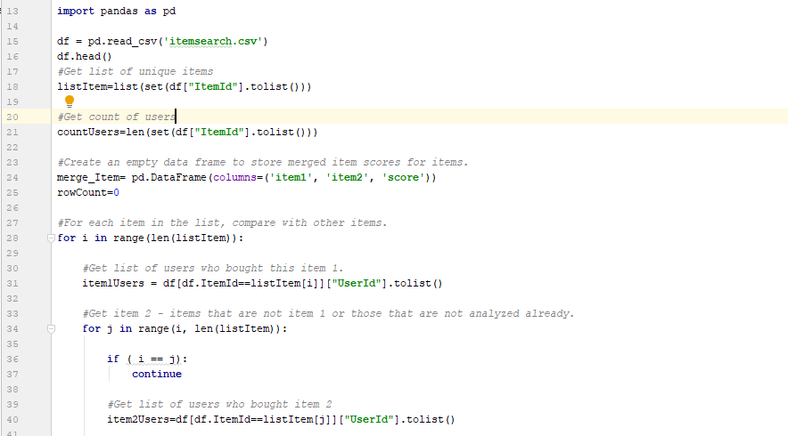We took some of AI example codes to get ideas for our project. This is a python application that recommends products to a customer on any e-commerce website. This is a recommendation system to recommend products to a customer on any e-commerce website. Recommendations should be based on the products consumer has searched on other sites like Google or Amazon. So, this is a sample data set for implementing the feature.

**(Figure 51- This is a Figure of AI Python coding of Products recommendation system for customer)**

In here this coding is about Get list of unique items. Then, Get count of users. Then, create an empty data frame to store merged item scores for items. After that, for each item in the list, compare with other items. Then, Get list of users who bought this item 1. Then, Get item 2 - items that are not item 1 or those that are not analysed already.

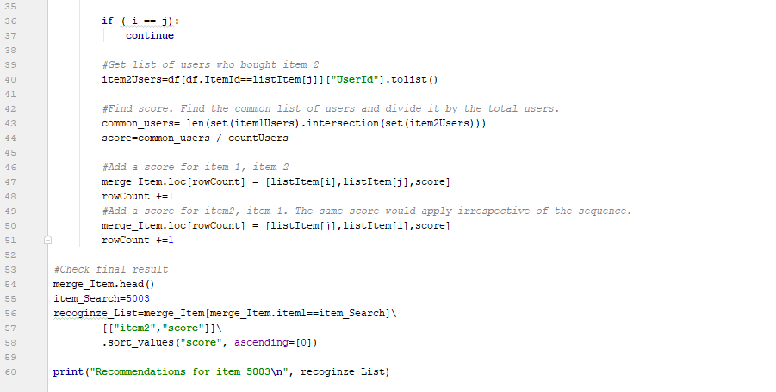

**(Figure 52- This is a Figure of AI Python coding of Products recommendation system for customer)**

In here this coding is about Get list of users who bought item 2. Then, Find score. Find the common list of users and divide it by the total users. Then, add a score for item 1, item 2. Then, add a score for item2, item 1. The same score would apply irrespective of the sequence. Then, Check final result as print recommendations for item recognize list. From this reference I got ideas to my project (Shopping-Recommendation-System, n.d.).

From this TensorFlow, we can Easy model building that meant we can Build and train ML models easily using intuitive high-level APIs like Keras with eager execution, which makes for immediate model iteration and easy debugging. Next, we can Robust ML production anywhere that meant easily train and deploy models in the cloud, on-prem, in the browser, or on-device no matter what language we use. Next, Powerful experimentation for research that meant A simple and flexible architecture to take new ideas from concept to code, to state-of-the-art models, and to publication faster.

In future we have idea to expand our smart trolley idea in to AI Chatbot with smart trolley. The latter uses deep learning and natural language processing (NLP) to give more than some pre-set answers. Their conversations are more human-like, they give insightful responses, and address the user’s needs. All these result in better engagement, more sales and happier customers. These AI-enabled personal assistants can give the status of an order to a customer and perform routine tasks like finding a particular product just by a customer’s description.

When Chatbots are also being integrated with shopping trolleys. Once we have integrated the chatbot with one of our shopping carts, it can work with all the stores based on the platform. Also, specific systems need shopping cart integration to retrieve information such as product details and quantities, shipping terms etc., and chatbots are used to provide accurate answers to our customers pertaining to these criteria.

In future we have idea to personalization of AI. We are using this technology some functions. We have idea to expand this. AI in trolley is perfectly suited to recommend products to our customers. This can done by big data analysing and AI is aware of our customer’s purchasing history, search inquiries, location of products, sometimes even their lifestyle changes, and all this can affect purchase decisions significantly. This capability of AI to analyse purchase history and expect needs is unparalleled by any other technology today. This will give most benefits. They are Encourages customers to return to our store, Guarantees higher visitor retention, which in turn translates into higher sales, provides an improved customer experience and greater revenue for the retailer and Helps generate valuable data for email and other marketing campaigns.

We will create Personalization app in future because it uses real-time AI predictive analysis to recommend products to our customers and act more like a personal shopping assistant to them. Personalization’s automated emails help customers create AI powered email campaigns on any platform. In future we have idea to use in smart trolley image recognition. It’s again AI. Because, fruits and vegetables get price by barcode or RFID tags is not practical. So, if we use image recognition it will easily identify those by shapes with AI.

In future we will implement Artificial intelligence in cyber security of the main server computer. It can prevent or detect any fraudulent activities. This main computer has to deal with a lot of transactions on daily basis. Cybercriminals and hackers can hack the user account to gain unauthenticated access. This can lead to the exposure of private data and online fraud. The reputation of the business also gets a big blow. To prevent this, **Artificial intelligence and machine learning** algorithms are developed that can mitigate the chances of fraud activities over the main computer.

In future, main computer can make better decisions with the application of Artificial intelligence. Data analysts have to handle a lot of data every day. This data is too huge for them to handle. Moreover, analyzing the data also becomes a difficult task. Artificial intelligence has fastened the decision-making process of main computer in business organizations. AI algorithms can easily identify the complex patterns in the data by predicting user behavior and their purchasing pattern.

So, we implemented our smart trolley with considering the project aim, cost and time. We have idea to expand our shopping smart trolley in to more feature and quality. We will expand this smart trolley in to most AI and IOT functionalities based in future.

(Author’s view), (Shopping-Recommendation-System, n.d.) ,

(link.springer.com, n.d.)

### 4.4.3 Diagrams for our Smart Trolley

#### Block Diagram

This is a basic used components diagram design for smart trolley project.

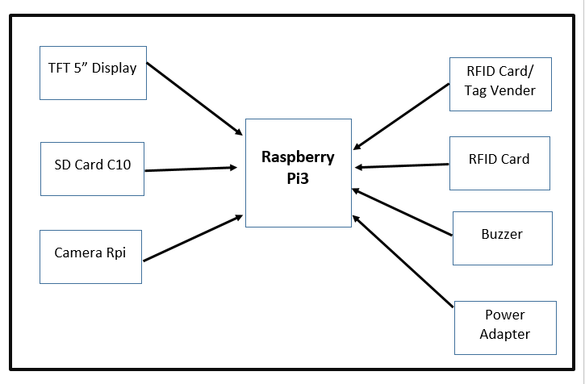

**(Figure 53- This is a Figure of Block diagram)**

#### Flow chart

This is a data flow of smart trolley project.

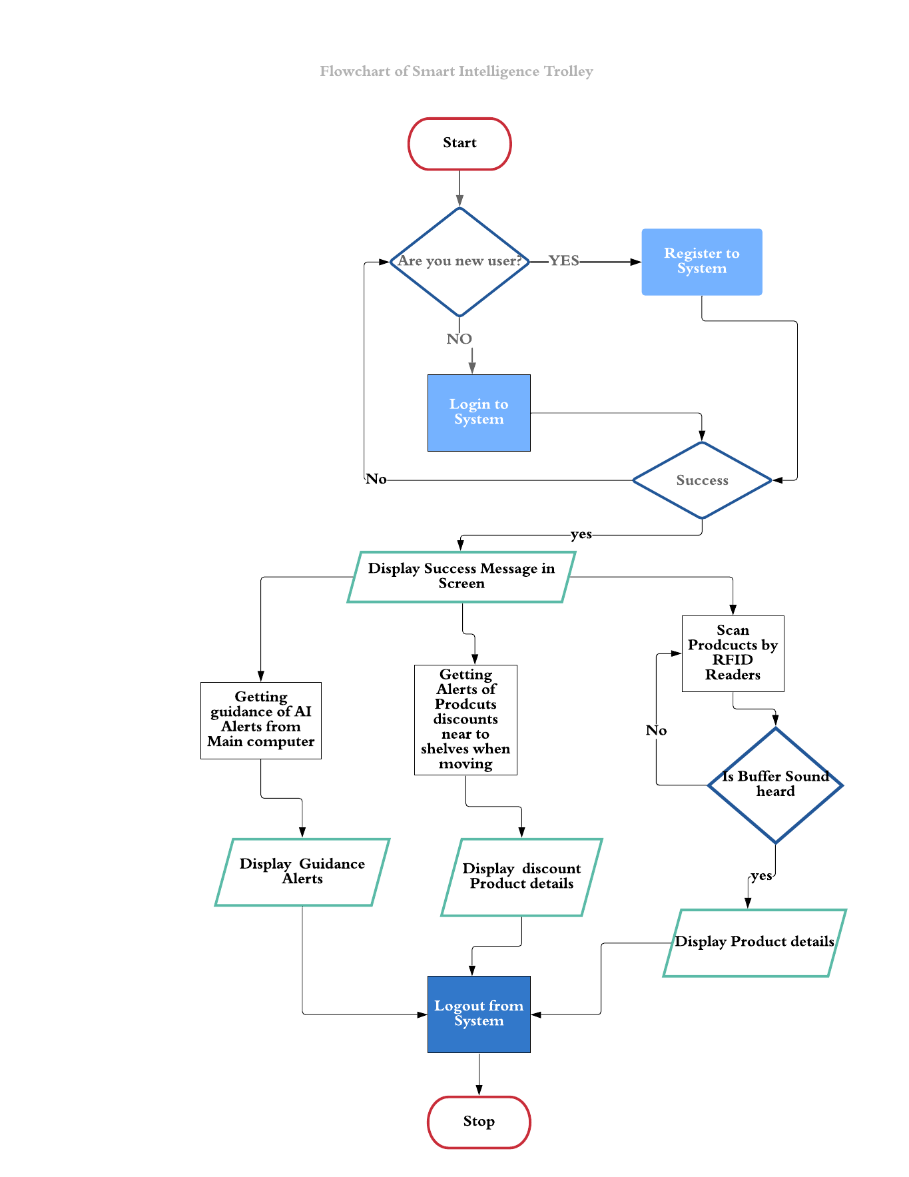

**(Figure 54- This is a Figure of Flow chart)**

#### Schematic Diagram

We used for smart trolley Raspery pi3, TFT 5” Display, SD Card C10, Power Adapter, Camera Rpi, RFID Card/ Tag Vender, RFID 125MHz Card, Project Box Medium and Buzzer. This is a design for this project. We used fritzing software to designing.

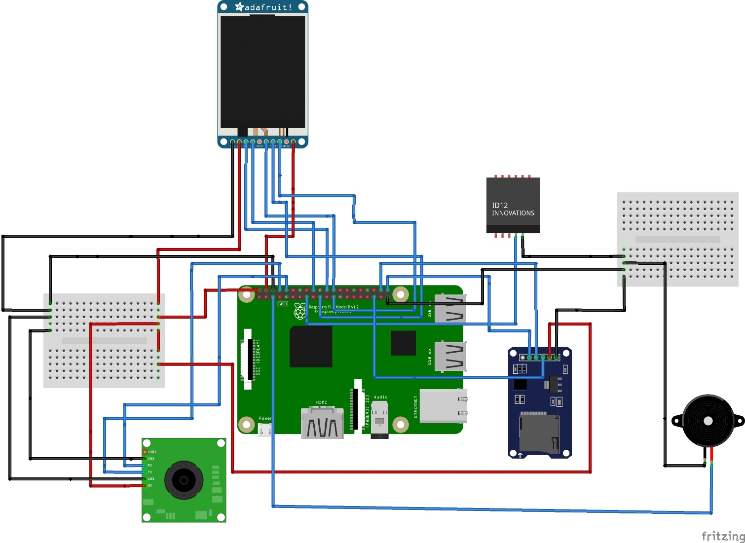

***(Figure 55- This is a Figure of Schematic Diagram)***

**)**

## Tools and Techniques:

### 4.5.1 Tools

* TFT 5” Display
* Power Adapter
* Trolley Unit
* Camera Rpi
* SD Card C10
* Wireless Networking
* AI Software (Tensor flow)
* Raspery pi3
* RFID Card/ Tag Vender / IR sensor
* RFID 125MHz Card
* Project Box Medium
* Buzzer

### 4.5.2 Techniques

* Agile development method (Scrum)
* Factory Design Pattern

(Author’s view)

## **Answering the academic question**.

Our Project about implementing a smart trolley using with IOT (Internet Of Things) and AI (Artificial Intelligent). Reasons of this project which I choose are because implement as a final project in HND. I choose this smart trolley because after doing many final projects not use in practically. Because we need to control large area public. That is not practical. But, If we focus small area usable project meant that will be easily use by public and easily control also. Business is day to day developing. If we doing any projects focus on business meant that can be very much success. Business and IT joined projects are valuable. This Smart trolley with IOT and AI is increase customer satisfaction and reduce waste time. In supermarket AI will guides customers through the IOT devices.

But, in here is an issue that was we developed only prototype. That meant sample project. This project is not in customer usable way. So, we have to customize and we have to reduce the size of this prototype by giving any manufacturing company. So, again that will be take time, cost and effort. If we move like these AI and IOT projects meant best for business. But, if we consider the normal customers meant they will prefer not like these technology. That can be an issue for this project. If we using AI meant, it will take many time practice. But, in supermarkets we can’t sure every AI work perfect.

So, after did our project this smart trolley is we have to implement as prototype not in business product. So, we don’t need to consider that part. If we have to earn from this project meant we can give to any start-ups to manufacture. Again, now a day’s almost every customer’s preference is not normal way. They prefer to shopping using different technology. So, it not depend on customer status. Again, we are doing HND final project. We do our best for project within time period. We don’t need to consider the training AI at supermarket level. Within our period we practice our AI best meant its ok.

This project period is about six months. Eleventh of January 2019 is the date which started for planning. Three weeks for project Proposal. After that we researched about project and implemented the project. Finally, on 29th of July we have to submit this Project. If we consider time frame we failed to manage time. So, that’s also one of issue. After that sir gave extension to do the project. This project will done by with the guidance of Research Project Lecturer Mr. Anis Saboordeen and myself. This project is mainly focus for clients. They are Supermarket owners, staffs, and customers of supermarket. So, they are also involving to this project. So, when we were researching we have lots of doubts. That’s also one problem with us. At that time we can’t continue our researching. After, that we contact the sir and clarify the doubts and continue our project.

We did this project step by step. First step researched about project in clear and plan the project. Then, we did project proposal. Then, we collected our hardware and software requirements. We researched continuously because to update new features to our project. Then, we studied programming for IOT devices and AI coding. Then, we implemented Artefact first. Then, we implemented the AI. We created an Artefact. After that we tested the project. Finally, we will submit this project. So, in these steps sometimes time and cost of products are a main issues. Sometime internet is an issue. But, however we handled those issues with correct ways. Then, we managed time and cost very well (Author’s view).

## Plan/Schedule

#### 4.7.1 Gantt chart

**(Figure 56- This is a Figure of Gantt chart)**

#### 4.7.2 Work break structure

**(Figure 57- This is a Figure of Work Break Structure of Initiating and Planning Phase)**

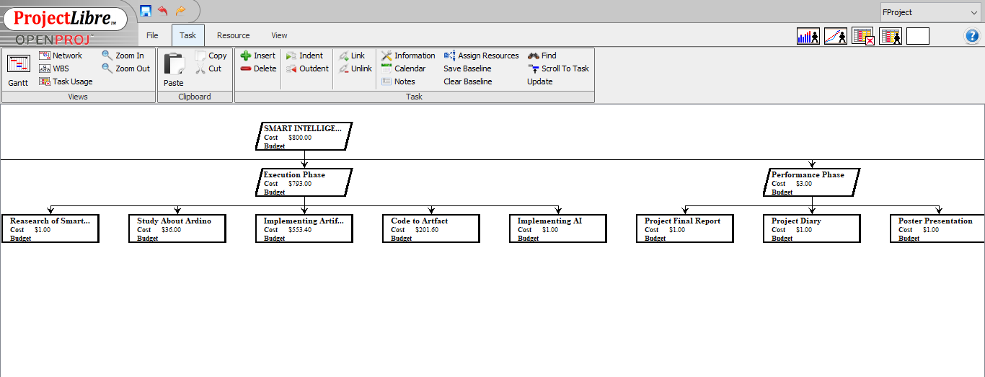

**(Figure 58- This is a Figure of Work Break Structure of Execution and Performance Phase)**

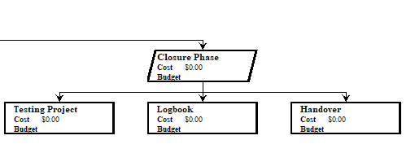

**(Figure 59- This is a Figure of Work Break Structure of Closure Phase)**

#### 4.7.3 Active network diagram

**(Figure 60- This is a Figure of Active network diagram)**

#### 4.7.4 Time plan with Resources

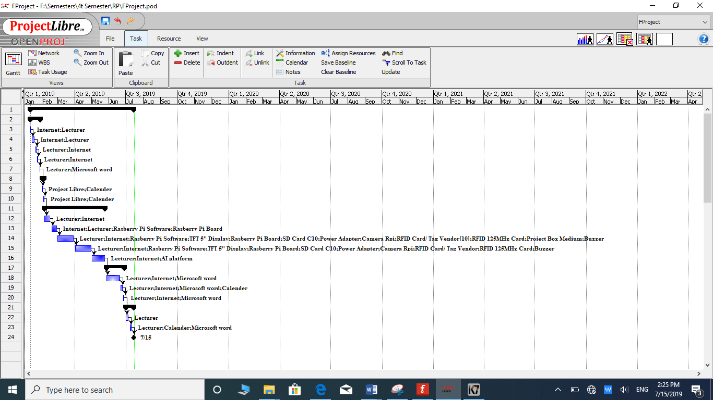

**(Figure 61- This is a Figure of Time plan with Resources)**

## Cost Analysis

|  |  |  |
| --- | --- | --- |
| **Products name** | **Price** | **Quantity** |
| Raspery pi3 | $35 | 1 |
| TFT 5” Display | $ 79 | 1 |
| SD Card C10 | $10 | 1 |
| Power Adapter | $0.5 | 1 |
| Camera Rpi | $29 | 1 |
| RFID Card/ Tag Vender | $39 | 1 |
| RFID 125MHz Card | $8.00 | 10 |
| Project Box Medium | $0.8 | 1 |
| Buzzer | $0.1 | 1 |
| **Total Price** | $201 |  |

**(Chart 1- This is a Chart of Cost Analysis)**

## 4.9 Conclusions

We create best AI and IOT base Artefact for Supermarket trolleys because business organization can get high customer satisfaction from these Supermarket trolleys, reduce the queue waiting time and wasting time in the supermarket and reduce labour cost. So, for that, we learnt about IOT, Arduino and its coding, AI platforms and Python coding. We bought hardware IOT devices.

From this smart trolley in the shopping market; Customers can add products to trolley that will automatically add cost and details of the products in the system, Customers can search items through the smart trolley will guide them where the products is placed in the store and Customer has limited access to these smart trolleys.

When we are using smart trolley shopping will be easy, comfortable and speed of services. The company can manage the products in a convenient manner, automated self-billing by customer, Hassle free shopping, Maintaining individual Customer Purchase data are the main advantages of this project. So, AI will collect these customer and products details and analyse those data. Then, guide to customers wherever help need as an assistant. The guidance is through the display the messages in Smart shopping trolley display. So, AI and IOT are main part for this success of the project (Author’s view).

## Critical evaluation of the product

We created AI based smart shopping trolley for my HND final project. We used for smart trolley Raspery pi3, TFT 5” Display, SD Card C10, Power Adapter, Camera Rpi, RFID Card/ Tag Vender, RFID 125MHz Card, Project Box Medium and Buzzer hardware devices. We used Arduino software, AI platforms, Project libre, Fritzing as a software we used in our project.

I choose smart trolley project because after doing many final projects not use in practically. Because we need to control large area public. That is not practical. But, If we focus small area usable project meant that will be easily use by public and easily control also. Business is day to day developing. Every each organization thinks to overcome from their competitors. If we doing any projects focus on business meant that can be very much success. Business and IT joined projects are valuable. This Smart trolley with IOT and AI is increase customer satisfaction and reduce waste time and reduce waste cost. In supermarket AI will guides customers through the IOT devices. We developed this project step by step.

We did our project in five phases. They are Initiation Phase, Planning Phase, Execution Phase, Performance Phase and Closure Phase. In Initiation Phase we included Research about IOT & AI, Research All the possible Projects, within those projects Choice of My Project, Literature Review and Project Proposal. In Planning Phase we included Work Break Structure, Gantt chart. In Execution Phase we included research of Smart trolley, Study about Arduino, Implementing Artefact, Code to Artefact and Implementing AI. In Performance Phase we included Project Final Report, Project Diary, and Poster Presentation. In Closure Phase we included Testing Project, Logbook and Handover the project.

In our smart trolley, there is a large screen on the top of trolley. When customer enter to supermarket then, they just login to the system via screen. Every products have RFID tags. If we add any products to the trolley those products detect by RFID readers and send the details of products to display. Such as image and the name of products, price of products, quantity of products and total price of products. Every products which we add for purchase whole details should display in the screen. When we are adding and removing products will conform by IR sensors. We will use Power Adapter to power supply.

In here, we are using screen authenticate. This is easy when we are in supermarkets only. So, we can view all the messages at supermarkets only. If we consider the other organizations meant they send those messages mainly at super markets and some of offers of products in the home also through the mobile application. So, customers can view their purchases and details in their mobile in any time. So, in future we have to develop a mobile application for our smart trolley. In future we have idea to use in smart trolley image recognition. It’s again AI. Because, fruits and vegetables get price by barcode or RFID tags using is not practical. So, if we use image recognition it will easily identify those by shapes with AI.

There are shelves with sensors. This is send information about that shelf contain discount products. When we are crossing those shelves those sensors connected with our trolley screen via network. So, those information of discount products will get as pop up messages in the trolley screen. When we are selecting the products which for buy we can know exact price of those products. And we can reduce our shopping expenditure. In here this system is run in main computer. That computer stores every each customer data. There is a counter computer in supermarket. After finish our shopping; trolley screen will sends the information about products details of purchase before we reaches the counter. So, counter computer and our screen is connected with each other in network. Then, we don’t need to wait for queue. We know about our total price before the cashier knows the total price. So, we can easily ready our payment by card or money. So, this is main advantages and aim of this IOT smart trolley. These devices connected with each other by wi-fi. If the wi-fi connection is weak meant these devices will not work. In here main disadvantage is if one device hacked meant fully devices can hack and hackers can get the whole data’s’ of business organization.

In AI using ways are; when we are shopping time system will analyse last shopping’s and remembering the products which we like to buy. If the products is expiry meant system will inform us. If the customer is male meant if he select any item from female or baby that will inform to customer. Analyse the previous shopping’s budget and remembering the budget if the budget is overrun meant. When customer shopping time system will send the special offer, discounts and points messages. Then, screen will navigate those products places. That system will inform upcoming products which customer like and purchasing most. So, these information will display in display.

These AI functionalities increases customer satisfaction. So, these will reduce the wasting time in shopping market. Sometimes these predictions can be unsuitable predictions. If the customer is male meant if he select any item from female or baby that will inform to customer. So, sometimes customer can selected products for their family members. So, from that if AI inform products by gender wise meant that will be wrong informing.

Finally, if we take any products there have advantages and disadvantages in those products. So, in our smart trolley project almost advantages with most success. We have ideas to expand our ideas to improve our project with new features with AI and IOT functionalities.

(Author’s view).

## 4.11 References and Bibliography

* link.springer.com, n.d. *link.springer.com.* [Online]   
  Available at: https://link.springer.com/chapter/10.1007/978-981-10-9059-2_33  
  [Accessed 28 01 2019].
* Shopping-Recommendation-System, n.d. *Shopping-Recommendation-System.* [Online]   
  Available at: https://github.com/babita4312/Shopping-Recommendation-System/commit/d4556ab11113a743abb19c363df1de0e84609d74  
  [Accessed 28 07 2019].
* www.adafruit.com, n.d. *www.adafruit.com.* [Online]   
  Available at: https://www.adafruit.com/?q=power  
  [Accessed 28 1 2019].
* www.ijraset.com, n.d. *www.ijraset.com.* [Online]   
  Available at: https://www.ijraset.com/fileserve.php?FID=10615  
  [Accessed 28 01 2019].
* *www.youtube.com/watch?v=40oH-dhtIK0&t=2s.* n.d. [Film] s.l.: s.n.
* *www.youtube.com/watch?v=40oH-dhtIK0.* n.d. [Film] Directed by www.youtube.com/watch?v=40oH-dhtIK0. s.l.: www.youtube.com/watch?v=40oH-dhtIK0.
* *www.youtube.com/watch?v=EgUB0mW6zRc&t=2s.* n.d. [Film] Directed by www.youtube.com/watch?v=EgUB0mW6zRc&t=2s. s.l.: www.youtube.com/watch?v=EgUB0mW6zRc&t=2s.
* *www.youtube.com/watch?v=jfzmetXKJs4&t=49s.* n.d. [Film] s.l.: s.n.
* *www.youtube.com/watch?v=jfzmetXKJs4&t=52s.* n.d. [Film] Directed by www.youtube.com/watch?v=jfzmetXKJs4&t=52s. s.l.: www.youtube.com/watch?v=jfzmetXKJs4&t=52s.
* *www.youtube.com/watch?v=KdT4miCTbds.* n.d. [Film] Directed by www.youtube.com/watch?v=KdT4miCTbds. s.l.: www.youtube.com/watch?v=KdT4miCTbds.
* *www.youtube.com/watch?v=NrmMk1Myrxc&t=36s.* n.d. [Film] Directed by www.youtube.com/watch?v=NrmMk1Myrxc&t=36s. s.l.: www.youtube.com/watch?v=NrmMk1Myrxc&t=36s.
* *www.youtube.com/watch?v=OeSqnLZXKM4&t=3s.* n.d. [Film] Directed by www.youtube.com/watch?v=OeSqnLZXKM4&t=3s. s.l.: www.youtube.com/watch?v=OeSqnLZXKM4&t=3s.
* *www.youtube.com/watch?v=OeSqnLZXKM4&t=4s.* n.d. [Film] s.l.: s.n.
* *www.youtube.com/watch?v=psPg3cgQYdc&t=22s.* n.d. [Film] Directed by www.youtube.com/watch?v=psPg3cgQYdc&t=22s. s.l.: www.youtube.com/watch?v=psPg3cgQYdc&t=22s.
* *www.youtube.com/watch?v=VaVRTBB2LVM&t=6s.* n.d. [Film] Directed by www.youtube.com/watch?v=VaVRTBB2LVM&t=6s. s.l.: www.youtube.com/watch?v=VaVRTBB2LVM&t=6s.